**Que: Which process is responsible for ensuring that the CMDB has been updated correctly?**

1. **Change Management**
2. **Problem Management**
3. **Configuration Management**
4. **Release Management**

Ans: C.

**Que: Which of the following details must be recorded for every CI in the CMDB?**

1. **Type identity**
2. **Unique identifier**
3. **Version number**
4. **Copy number**

Ans: Both A and B

**Que: Items of information stored in the CMDB relating to a specific CI are known as?**

1. **Components**
2. **Features**
3. **Characteristics**
4. **Attributes**

Ans: D.

**A Configuration Management Database (CMDB) can contain different Configuration Items (CIs). Which of the items below would NOT normally be regarded as a CI?**

1. **A user name**
2. **A video monitor**
3. **A bought-in software package**
4. **A procedure**

Ans: A.

**For which of the following activities is the Service Desk NOT responsible?**

1. **Impact analysis**
2. **Root cause identification**
3. **Categorisation and prioritisation**
4. **Escalation**

Ans: B.

**Which of the following is NOT part of the role of the Service Desk?**

* **Providing support to the user community**
* **Resolving the root causes of incidents**
* **Acting as day-to-day interface between IT services and users**
* **Monitoring the progress of incidents**

Ans: B.

**The network managers have excessive workloads and have no time to proactively manage the network. One of the contributing factors to these large workloads is the frequency that users contact these managers directly. which ITIL process would improve this situation?**

1. **Change Management**
2. **Configuration Management**
3. **Incident Management**
4. **Problem Management**

Ans: C.

**Que: A computer operator notices the full storage capacity of her/his disk will soon be used. To which ITIL process must this situation be reported?**

1. **Change Management**
2. **Configuration Management**
3. **Incident Management**
4. **Problem Management**

Ans: C.

**Que: A serious incident has occurred. The assigned solution team is unable to resolve this incident within the agreed time. The Incident Manager is called in. Which form of escalation describes the above sequence of events?**

1. **Formal escalation**
2. **Functional escalation**
3. **Hierarchical escalation**
4. **Operational escalation**

Ans: C.

**Que: From which document can the Incident Management process obtain information about when and to whom it must escalate issues if required?**

1. **The Service Improvement Program**
2. **The Service Catalogue**
3. **The organization chart**
4. **The Service Level Agreement**

Ans: D.

**Which of the following is NOT a Problem Management responsibility?**

1. **Ownership of an incident throughout its lifecycle**
2. **Investigation & Diagnosis**
3. **Raising Requests for Change**
4. **Maintenance of a known error database**

Ans: A.

**A known error occurs when:**

1. **An error has occurred several times and has been passed to Problem Management**
2. **An error occurs that has not been diagnosed and for which a circumvention does not yet exist**
3. **A problem has been diagnosed and a resolution or circumvention exists**
4. **The resolution of a problem has been implemented**

Ans: C.

**If a customer complains that service levels are below those agreed in the SLA because of a number of related hardware incidents, who is responsible for investigating the underlying cause?**

1. **The Incident Manager**
2. **The Service Level Manager**
3. **The Problem Manager**
4. **The Availability Manager**

Ans: C.

**Que: A user complains to the Service Desk that an error continually occurs when using a specific application. This causes the connection with the network to be broken. Which ITIL process is responsible for tracing the cause?**

1. **Availability Management**
2. **Incident Management**
3. **Problem Management**
4. **Release Management**

Ans: C.

**How does Problem Management support the Service Desk activities?**

1. **It resolves serious incidents for the Service Desk.**
2. **It studies all incidents resolved by the Service Desk.**
3. **It relieves the Service Desk by communicating the resolution directly to the user.**
4. **It makes information on a Known Error available to the Service Desk.**

Ans: D.

**Under an ITIL Change Management process, once a change has been built, who should undertake testing?**

1. **The change builder**
2. **The Change Manager**
3. **The Change Advisory Board**
4. **An independent tester**

Ans: D.

**Which of the following activities is the responsibility of Change Management?**

1. **Reviewing changes to ensure they have worked**
2. **Creating a change to rectify a known error**
3. **Determining the release strategy for a major change**
4. **Implementing a software change at a remote site**

Ans: A.

**Within an ITIL compliant Change Management process, who decides on the categorisation of a proposed change?**

1. **Change Manager**
2. **Change Advisory Board**
3. **Change Requestor**
4. **Change Implementer**

Ans: A.

**The data in the Configuration Management Database (CMDB) can only be modified after permission is granted to modify the infrastructure. Which process grants such permission?**

1. **Change Management**
2. **Configuration Management**
3. **Incident Management**
4. **Service Level Management**

Ans: A.

**After a Change has been implemented, an evaluation is performed.What is this evaluation called?**

1. **Forward Schedule of Changes (FSC)**
2. **Post Implementation Review (PIR)**
3. **Service Improvement Program (SIP)**
4. **Service Level Requirement (SLR)**

Ans: B.

**Which of the following activities is NOT part of the release process:**

1. **Moving software from the DSL to the development environment**
2. **Moving software from the DSL to the live environment**
3. **Moving software from the development to the test environment**
4. **Moving software from the live environment to the DSL**

Ans: A.

**Which of the following best describes ‘reliability’?**

1. **The combination of confidentiality, integrity and maintainability**
2. **The ability of a service to remain functional even though some components have failed**
3. **The ability of a CI to remain functional under given conditions**
4. **The ability of a CI to be retained in, or restored to, an operational state**

Ans: C.

**What is the description of the term Confidentiality as part of the Security Management process?**

1. **Protection of the data against unauthorized access and use**
2. **Ability to access data at any moment**
3. **The capacity to verify that the data is correct**
4. **The correctness of the data**

Ans: A.

**Which of the following is NOT a responsibility of the IT Service Continuity planning team?**

1. **Outlining possible measures to protect an IT service**
2. **Deciding the business criticality of an IT service**
3. **Testing the plans for recovery of an IT service**
4. **Identifying the risks to an IT service**

Ans: B.

**Which of the following would you NOT expect to see in an IT Service Continuity Plan?**

1. **Contact lists**
2. **The version number**
3. **Reference to change control procedures**
4. **Service Level Agreements**

Ans: D.

**Which of these is not part of Capacity Management?**

1. **Tuning**
2. **Demand Management**
3. **Application sizing**
4. **Maintainability**

Ans: D.

**Which of the ITIL processes is responsible for ensuring the organisation is aware of new and changing technology?**

1. **Capacity Management**
2. **Change Management**
3. **Financial Management for IT Services**
4. **Configuration Management**

Ans: A.

**Which ITIL process draws up a (long-range) plan for the expected purchase of IT Services?**

1. **Capacity Management**
2. **Change Management**
3. **Financial Management for IT Services**
4. **Configuration Management**

Ans: A.

**The Service Level Manager requires confirmation that the internal Service Desk can answer a certain percentage of calls within 10 seconds. In which document would the Service Desk’s agreement to this requirement be recorded?**

1. **Internal Specification Sheet**
2. **Operational Level Agreement**
3. **Service Level Agreement**
4. **An underpinning third party contract**

Ans: B.

**In which two service Management processes would you be most likely to use a risk analysis and management methodology?**

1. **Change & Cost Management**
2. **Availability Management & IT Service Continuity Management**
3. **Incident & Change Management**
4. **Service Level Management & IT Service Continuity Management**

Ans: B.

Overview

Service

Service is a means of delivering value to customers by achieving customer's desired results while working within given constraints.

Services vs. Products

|  |  |
| --- | --- |
| **Services** | **Products** |
| Services are not tangible. | Products are tangible. |
| Services are produced and consumed at same time. | Products are not produced and consumed at same time. |
| Services are inconsistent. | Products are consistent. |
| The user participates in the production of services. | The user doesn’t participate in the production of products. |

Service Management

Service Management refers to all aspects of the management of IT service provision. According to ITIL, Service management contains all organizational capabilities for generation of added value to the customers as service.

Goals of Service Management

Here are the main goals of Service management:

* Make IT services adaptable towards the present and future requirements of an organization and its customers.
* Develop and maintain good & responsive relationship with the business.
* Make effective and efficient use of all IT resources.
* Optimizing the quality of delivered services.
* Reduction of long term cost of service delivery.

Achieving Service Management

Here are the key activities needed to be performed in order to achieve business and customer’s satisfaction:

* Documenting, negotiating and agreeing customer and business quality targets and responsibilities in Service Level Agreements (SLAs)
* Regular assessment of customer opinion in customer feedback and customer satisfaction surveys.
* IT personnel taking the customer and business perspective and always trying to keep customer interactions as simple as possible.
* Understanding the ICT infrastructure.
* IT personnel regularly taking the customer journey and sampling the customer experience.

ITIL Tutorial

ITIL is a framework providing best practice guidelines on all aspects of end to end service management. It covers complete spectrum of people, processes, products and use of partners.

Now a day’s ITIL is being practiced by almost every company providing IT services to the customers.

Audience

This tutorial has been prepared for the students as well as professionals to ramp up quickly. This tutorial is a stepping stone to ITIL certification.

Prerequisites

Before proceeding with this tutorial you should know the basic terms such as Information Technology, Infrastructure, Services, and Service Level Agreements etc. Hence it is strongly recommended to go through **ITIL Terminologies** chapter before proceeding further.

ITIL Overview

**ITIL** is a framework providing best practice guidelines on all aspects of end to end service management. It covers complete spectrum of people, processes, products and use of partners.

Now a day’s ITIL is being practiced by almost every company providing IT services to the customers.

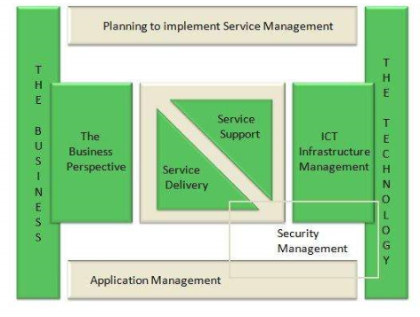

The processes, tasks and checklists described in ITIL are not organization-specific, but can be implemented by any organization. It gives organization a framework to plan, implement and measure IT services.  
ITIL was published in 1989 by **Her Majesty's Stationery Office (HMSO)** in **UK** on behalf of the **Central Communications and Telecommunications Agency (CCTA)**, now subsumed within the Office of Government Commerce (OGC).

Why ITIL is required?

ITIL helps business managers and IT managers to deliver services to the customers in effective manner and hence gaining the customer’s confidence and satisfaction. Here are the areas where ITIL plays an effective role:

* IT and business strategic planning
* Integrating and aligning IT and business goals
* Implementing continuous improvement
* Acquiring and retaining the right resources and skill sets
* Reducing costs and the Total Cost of Ownership
* Demonstrating the business value to IT
* Achieving and demonstrating Value for Money and Return on Investment.
* Measuring IT organization effectiveness and efficiency
* Developing business and IT partnerships and relationships
* Improving project delivery success
* Managing constant business and IT change

ITIL Versions

ITIL was originated as collection of books. These books of ITIL cover all aspects of IT service management. Since its origin, it has undergone many changes which lead to the following versions of ITIL:

* **ITIL V1** was the initial version of ITIL consisting of 31 books
* From 2000 to 2004, **ITIL V1** was revised and replaced by 7 books (ITIL V2). This version became globally accepted and is now used in many countries by thousands of organizations
* In 2007, ITIL v2 was modified and consolidated with 3rd version of ITIL, consisting of five core books covering the service lifecycle. ITIL V3 included **26 processes** and **4 functions**
* In 2011, the 2011 edition of V3 was published. It was an updated version released in 2007.

ITIL Publications

ITIL core publications include a set of five manuals: **Service Strategy, Service Design, Service Transition, Service Operation** and **Continual Service Management.**

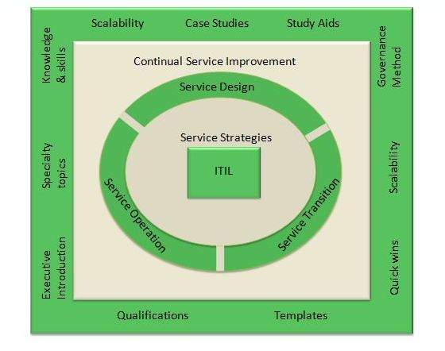

Benefits of ITIL

Following diagram shows several benefits of ITIL:

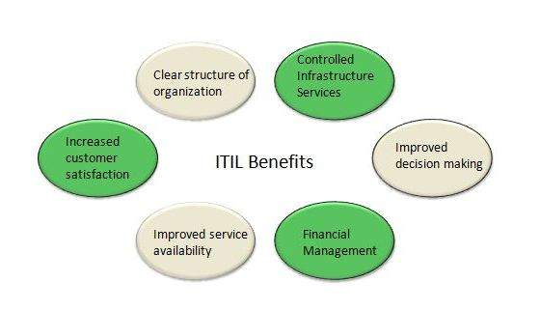

ITIL V2 vs. ITIL V3

|  |  |
| --- | --- |
| **ITIL V2** | **ITIL V3** |
| Focused on product, process and people. | Focused on product, process, people and partner. |
| Process oriented approach | Lifecycle based approach. |
| Security management is part of evaluation | Security management is a separate process |
| Emphasizes on service design and service strategy | Equal attention to all processes |
| Have 10 processes and 2 functions | Have 26 processes and 4 functions. |

ITIL Terminologies

Here in this chapeter, we will discuss some basic terminologies of ITIL that will help to understand the tutorial easily and quickly. The following table comprises of all basic terminologies required to learn ITIL:

|  |  |
| --- | --- |
| **S.N.** | **ITIL Terminologies** |
| 1. | **ITIL** **Information Technology Infrastructure Library** is a set of best practices being practiced by most of the infrastructure service providers to deliver services to the customers to meet their business needs within predicted cost and quality. |
| 2. | **Service** **Service** is a means of delivering value to customers by achieving customer's desired results while working within given constraints. |
| 3. | **Service Level** It is measured and reported achievement against one or more Service Level Targets. |
| 4. | **Service Level Agreement** It is agreement between service provider and customer. The SLA describes the IT Service, documents Service Level Targets and specifies the responsibilities of provider and customer. |
| 5. | **Service Strategy** **Service Strategy** helps to design, develop and implement service management as organizational capabilities and strategic assets as well. It enables a service provider to consistently outperform competitive alternatives over time, across business cycles, industry disruptions and changes in leadership. |
| 6. | **Service Model** **Service Model** is the high level description of the service and components required to deliver that service. |
| 7. | **Service Portfolio** **Service Portfolio** is the set of services provided by the service provider. |
| 8. | **Service Catalogue** **Service Catalogue** is the set of specific services being provided by service provider to a specific customer. |
| 9. | **Customer Portfolio** **Customer Portfolio** is used to record all customers of IT service provider. |
| 10. | **Demand Management** **Demand Management** is very important and critical process in service strategy. It helps to understand customer demand for services so that appropriate capacity can be provisioned to meet those demands. |
| 11. | **Pattern of Business Activity** **PBA** is an extremely important activity achieved by knowing customer how they operate and future requirement they might need. |
| 12. | **Service Design** **Service Design** provides a blueprint for the services. It not only includes designing of new service but also devises changes and improvements to existing ones. |
| 13. | **Operational Level Agreement (OLA)** **OLA is an agreement between IT service provider and another part of same organization.** |
| 14. | **Service Level Report** It gives insight into a service provider’s ability to deliver the agreed service quality. |
| 15. | **Service Level Requirements** It is a document containing the requirements for a service from the client viewpoint, defining detailed service level targets. |
| 16. | **Service Asset** **Service Assets** are the resources and capabilities owned by the service provider enabling it to deliver service to the customer. |
| 17. | **Configuration Item (CI)** **Configuration Item** is subset of service assets and have direct impact on delivering services. All servers, networks, applications that have impact on production are known as configuration item. |
| 18. | **SACM** **Service Assets and Configuration Management (SACM)** deals with maintaining up-to-date and verified database of all assets and CIs which are also made available to other service management processes. |
| 20. | **Change** Change refers to modifying existing services. |
| 21. | **Event** **Event** is defined as detectable occurrence that has significance for the delivery of IT service. Events are created by Configuration Item (CI) or the monitoring tools. |
| 22. | **Incident** **Incident** is defined as any disruption in IT service. Incident can be reported either through the Service Desk or through an interface from event management to incident management tools. |
| 23. | **Service Request** **Service Request** refers to demand by the users. These requests can be regarding small changes, changing the password, installing additional software application, requesting information etc. |
| 24. | **Problem** In ITIL, Problem is defined as unknown cause of one or more incident. |
| 25. | **Known Error** **Known Error** is well identified problem with its cause and resolution. It is stored in **Known Error Database (KEDB).** |

Service Lifecycle

[Previous Page](http://www.tutorialspoint.com/itil/service_basics.htm)

[Next Page](http://www.tutorialspoint.com/itil/service_strategy_overview.htm)

The complete framework of ITIL is based on service lifecycle. Each lifecycle defines certain processes for effective service management.

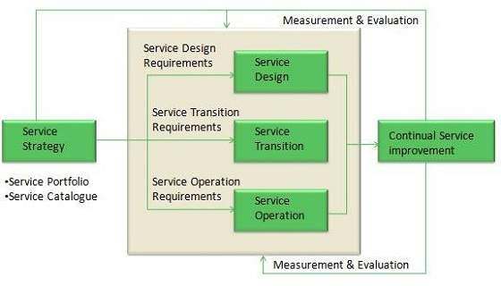

Service lifecycle helps to amplify the service management approach and to achieve better understanding of its structure. In the coming chapters, we will be discussing all lifecycle individually with their processes and functions.

Processes and Functions

There are 26 processes and 4 functions in ITIL V3. These processes and functions are discussed in detail with each service lifecycle in further chapters.

Process

A process defines policies, standards, guidelines, activities, and work instructions. It takes some defined inputs to produce desired results.

Functions

A function is defined as group of people or tools required to carry out one or more processes and activities.

# Service Strategy Overview

[Previous Page](http://www.tutorialspoint.com/itil/service_lifecycle.htm)

[Next Page](http://www.tutorialspoint.com/itil/service_strategy_roles.htm)

**Service Strategy** helps to design, develop and implement service management as organizational capabilities and strategic assets as well. It enables a service provider to consistently outperform competitive alternatives over time, across business cycles, industry disruptions and changes in leadership.

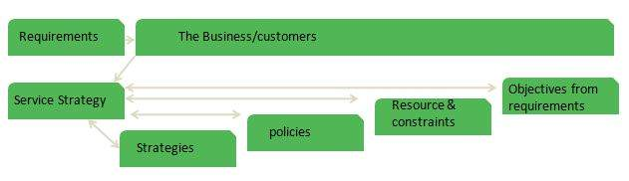

Service strategy comprises of the following key concepts:

* Value creation
* Service Assets
* Service Provider types
* Service structures
* Defining the service market
* Developing service offerings
* Financial management
* Service portfolios
* Demand management
* Return on investment

Strategic Assessment

Before crafting service strategy, a provider should first take a careful look at what it does already. The following questions can help expose a service provider’s distinctive capabilities:

* Which or our services or service verities are the most distinctive?
* Which or our services or service verities are the most profitable?
* Which of our activities in our value chain or value network are the most different and effective?

Factors in Strategic Assessment

Here are the key factors that play important role in strategic assessment:

|  |  |
| --- | --- |
| **S.N.** | **Description** |
| 1. | **Strengths and weaknesses** The attributes of the organization. For example resources and capabilities, service quality, skills, cost structures, product knowledge, customer relationship etc. |
| 2. | **Business Strategy** The perspective, position, plans and patterns are received from a business strategy. |
| 3. | **Critical Success factors** How will the service provider know when it is successful? |
| 4. | **Threats and opportunities** Includes competitive thinking. For example, is the service provider vulnerable to substitution?, or Is there a means to outperform competing alternatives? |

Value Creation

Service strategy defines a unique approach for delivering better value. According to customers service consist of two elements:

* Utility
* Warranty

Utility

Utility is perceived by the customer from the attributes of the service that have positive effect on the performance of task associated with the desired business outcomes. This is fir for purpose.

Utility is generally stated in terms of:

* Outcomes supported
* Ownership costs and risks avoided

Warranty

Warranty ensures the utility of the service is available as needed with sufficient capacity, continuity, and security. Value of warranty is communicated in terms of level of certainty.

Warranty is usually defined in terms of availability, capacity, continuity, and security of the utilization of the services.

**Availability**

It assures the customer that the services will be available for use under agreed terms and conditions.

**Capacity**

It assures that the service will support a specified level of business activity or demand at a specified level.

**Continuity**

It assures that the service will continue to support the business through major failures.

**Security**

It assures that the service provided by the service provider will be secure.

Service Assets

There are two types of service assets as listed below:

* Resources
* Capabilities

Resources

Resources are the inputs for production. The resources are transformed by management, organization, people and knowledge.

Capabilities

Capabilities refer to skills to develop and control the resources for production. The skills are based on knowledge, experience and information.

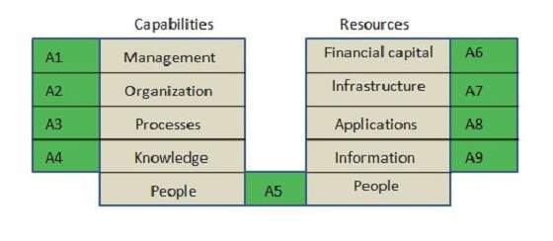

Service Provider Types

Service Provider can be broadly classified into three types as listed below:

1. Type I – Internal Service Provider
2. Type II – Shared Service Provider
3. Type III – External Service Provider

Type I Internal Service Provider

Internal Service provider refers to the business functions within an organization. Administration, finance, human resources, and IT service providers all comes under internal service providers.

Type II Shared Service Provider

In this, business functions such as IT, human resources, and logistics are consolidated into an autonomous special unit called a Shared Service Unit (SSU).

Type III External Service Provider

External service provider refers to the third party service providers. It can offer competitive prices and drive down unit cost by consolidating demand.

The Four Ps of strategy

The below mentioned Four Ps identify the different forms of a service strategy and are considered as entry points to service strategy.

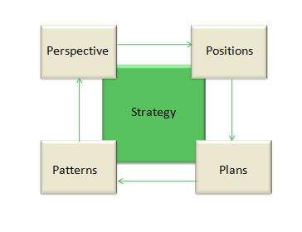

Perspective

It describes a vision & direction and articulates the business philosophy of interacting with customer.

Positions

It describes the decision to adopt a well-defined stance. It is expressed as distinctiveness in minds of customers. This means competing in the same space as others but with differentiated value proposition that is attractive to the customer. Whether it is about offering a wide range of services to a particular type of customer or being the lowest cost option, it is a strategic position.

Plan

A plan describes “How do we offer high value or low cost services? “ or “How do we achieve and offer our specialized services? “

Pattern

It describes the organization’s fundamental way of doing things.

Services strategy processes

The following diagram expresses the different processes and their relationship in service strategy:

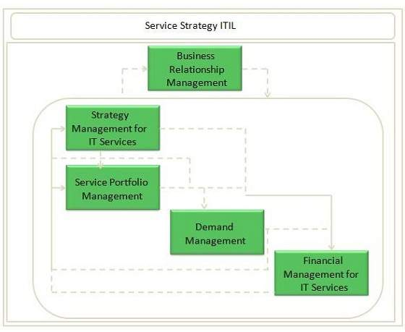

Strategy Management

This process involves four activities: **definition of market, development of offering, development of strategic assets,** and **preparation for the implementation of the strategy.**

Service Portfolio Management

Service portfolio defines all services that a service provider can provide. It helps to control service management investments throughout an enterprise and actively managing their value.

Business Relationship Management

This process deals with establishing good relationship between service provider and customers by ensuring that appropriate services are developed to meet customer’s needs.

Demand Management

This process maintains balance between consumption of services and their delivery.

Financial Management

Financial management helps to determine all the costs of IT organization. It can serve as a strategic tool for all three kinds on service provider types: internal, external and shared service provider.

# Service Strategy Roles

[Previous Page](http://www.tutorialspoint.com/itil/service_strategy_overview.htm)

[Next Page](http://www.tutorialspoint.com/itil/strategy_generation.htm)

There are several roles that are responsible for managing different key aspects of Service Strategy. Here we will discuss all of the roles in this chapter.

|  |  |  |
| --- | --- | --- |
| **S.N.** | **Role** | **Responsibility** |
| 1. | Business Relationship Manager | * Maintains good relationship with customers * Identifies customer’s needs * Ensures service provider meet customer’s need * Works closely with Service Level Manager |
| 2. | Demand Manager | * Responsible for understanding, anticipating, and influencing customer demand for services * Works with capacity manager to ensure that service provider has sufficient capacity to meet the required demand |
| 3. | Financial Manager | * Responsible for accounting, budgeting, and charging requirements |
| 4. | IT Steering Group (ISG) | * Sets direction and strategy for IT services * Reviews the business and IT strategies in order to make sure that they are aligned * Sets priorities of service development programs |
| 5. | Service Portfolio Manager | * Decides on a strategy to serve customers in cooperation with ISG * Develops service provider’s offering and capabilities |
| 6. | Service Strategy Manager | * Works with ISG in producing and maintaining the service provider’s strategy * Responsible for communicating and implementing service strategy |

# Strategy Generation

[Previous Page](http://www.tutorialspoint.com/itil/service_strategy_roles.htm)

[Next Page](http://www.tutorialspoint.com/itil/service_portfolio_management.htm)

For positive results, service provider needs to plan his services strategically. A good service strategy defines a unique approach for delivering better value.

Service Strategy Manager is the process owner of this process.

Service Generation Sub processes

Strategy Management comprises of four activities as listed below:

* Defining the market
* Developing offerings
* Developing strategic assets
* Measuring and Preparation for implementation of strategy

Defining the market

It is necessary to take survey of services available in the market. It gives a clear perspective of cost and quality of services already present and what new service can be offered in competitive environment.

Developing offerings

In this service provider develops a portfolio which contain all the services that are visible and available for the customer. Service portfolio is developed in order to represent all binding service investments towards the market.

Developing strategic assets

It deals with buying new technologies, resources and capabilities to offer law-cost and high-value service to the customer.

Measuring and Preparation for implementation of strategy

In order to measure success or failure of the strategy, all critical success factors are measured. Also the completion in the market is observed and priorities are adjusted accordingly.

# Service Portfolio Management

[Previous Page](http://www.tutorialspoint.com/itil/strategy_generation.htm)

[Next Page](http://www.tutorialspoint.com/itil/business_relationship_management.htm)

Service Portfolios

Service portfolio contains description of all the services engaged throughout the service lifecycle. It also represents the commitment and investment made by service provider across all customers and market spaces.

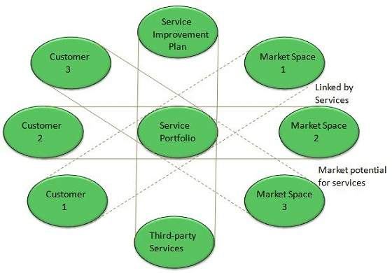

Service catalogue is subset of service portfolio and contains presently active services in service operation phase. We will discuss service catalogue in detail as part of service design process.

Service Portfolio Management

Service portfolio management ensures that the service provider is offering right combination of services to meet the customer’s need.

Service Portfolio Manager is the process owner of this process.

The purpose of service portfolio management is to provide answer to the following questions:

* Why should customer buy this service?
* Why should they buy from us?
* What form does the pricing structure take?
* What are our strengths and weaknesses, priorities and risks?
* How should we apply our resources and capabilities?

Sub Processes

Service portfolio management includes sub processes as shown in the following diagram:

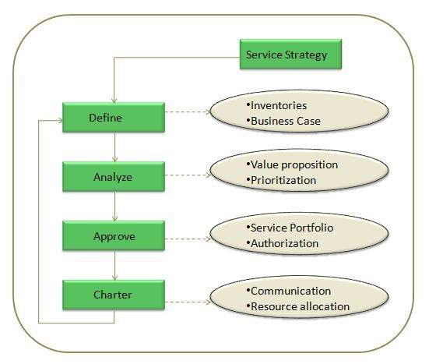

**Define**

The purpose of this process is to define desired results of a service.

**Analyze**

The purpose of this process is to analyze the impact of proposed new service or changed service on existing services in service portfolio.

**Approve**

The purpose of this process is to submit change proposal to change management and to initiate the design stage for the new or changed service if change proposal is authorized.

**Charter**

The purpose of this process is to communicate decisions, allocate resources and charter services.

# Business Relationship Management

[Previous Page](http://www.tutorialspoint.com/itil/service_portfolio_management.htm)

[Next Page](http://www.tutorialspoint.com/itil/demand_management.htm)

Relationship

A relationship is a connection between two people or things. In case of Business Relationship Management it is connection between IT service provider and the business while in Configuration Management it is a connection between two configured items that are dependent on each other.

**Business Relationship Management** process ensures good relationship between service provider and the customer. It is generally achieved by identifying, understanding, and supporting customer’s need and appropriate services are developed to meet those needs.

Business Relationship Management generally includes:

* Managing personal relationships with managers
* Providing input to Service Portfolio Management
* Ensuring that IT service provider is satisfying the customer’s need

Business Relationship Manager is the process owner of this process.

Sub-Processes

Business Relationship Management includes following sub-processes:

* Maintain Customer Relationship
* Identify Service Requirements
* Sign up customers to Standard Services
* Handle Customer Complaints
* Monitor Customer Complaints
* Customer Satisfaction Survey

Maintain Customer Relationship

This process ensures that service provider understands customer’s need and set up relationships with new potential customers.

Identify Service Requirements

This process ensures that service provider have complete understanding of output of a service and to decide if the customer’s need can be fulfilled using an existing service offering or if a new service needs to be created.

Sign up customers to Standard Services

This process deals with customer requirements and service level agreements.

Handle Customer Complaints

The objective of this process is to record customer’s complaints and take corrective action if required.

Monitor Customer Complaints

The objective of this process is to monitor the processing status of customer’s complaints.

Customer Satisfaction Survey

The objective of this process is to identify the scopes where customer expectations are not being met.

# Demand Management

[Previous Page](http://www.tutorialspoint.com/itil/business_relationship_management.htm)

[Next Page](http://www.tutorialspoint.com/itil/financial_management.htm)

**Demand Management** is very important and critical process in service strategy. It helps to understand customer demand for services so that appropriate capacity can be provisioned to meet those demands.

Improper demand management leads to improper use of services and resources. Hence it’s worth to analyze customer’s demand.

Demand Manager is the process owner of this process.

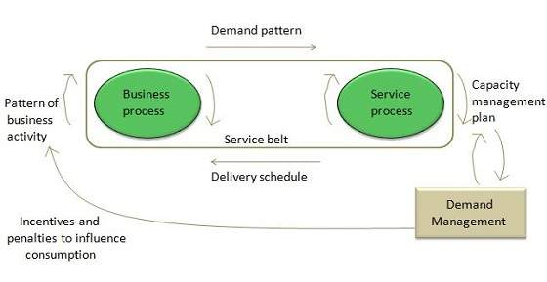

Stratigical Level Demand Management

Under Stratigical Demand Management we focus on two important things:

* Pattern of Business Analysis
* User Profiles

Pattern of Business Analysis (PBA)

**PBA** is an extremely important activity achieved by knowing customer how they operate and future requirement they might need.

User Profiles

It is the demand pattern shown by users. It can be processes, people or functions.

Tactical Level Demand Management

Under tactical level demand management we focus on Differential Charging. It is a technique to support Demand Management by charging different amounts for same IT Service Function at different times.

Challenges in Demand Management

Demand Management is critical process of service strategy. Following are the challenges that occur in this process:

* Improper analyses of customer’s demand leads to improper use of capacity. Excess capacity generates cost without creating value
* Sometimes certain amount of unused capacity is necessary to deliver service levels. Such capacity is creating value through the higher level of assurance made possible with the higher capacity
* It is required to have service level agreements, forecasting, planning, and tight coordination with the customer to reduce uncertainty in demand
* Service production cannot occur without concurrence presence of demand that consumes the output
* Arrival of demand is also influenced by demand management techniques such as off-peak pricing, volume discounts, and differentiated service levels

Service Packages

Core Services and supporting services

Core services are basic services for which customer is willing to pay. They bring actual value to the customer.

**Support services** enhance value proposition of core services i.e. added feature to key services.

Developing differentiated offerings

Packaging of core services and supporting services has implications for design and operation services. It is required to decide whether to standardize on the core or supporting services. One can arrive with same level of differentiation of in service offering taking different approaches to packaging as shown in the following figure.

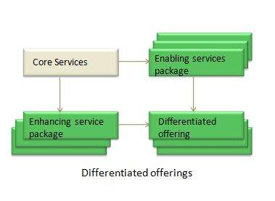

Service Level packages

Service packages come up with one or more Service Level Packages (SLP). Each of the service level packages provides definite level of utility and warranty from the perspective of outcomes, assets, and PBA of customers.

Business outcomes are the ultimate basis for service level packages.

# Financial Management

[Previous Page](http://www.tutorialspoint.com/itil/demand_management.htm)

[Next Page](http://www.tutorialspoint.com/itil/service_design_overview.htm)

**Financial Management** deals with accounting, budgeting and charging activities for services. It determines all the costs of IT organization on the basis of direct and indirect costs. This process is used by all three types of service providers – internal, external or shared service providers.

Financial Manager is the process owner of this process.

Benefits of Financial Management

Here are some of the benefits of Financial Management:

* Enhanced decision making
* Speed of change
* Service portfolio management
* Operational control
* Value capture and creation

Key decisions for Financial Management

Cost centre, value centre or accounting centre?

It is important to decide that how funding will be replenished. Clarity around the operating model greatly contributes to understanding the requisite, visibility of service provisioning costs, and funding is a good test of the business’s confidence and perception of IT.

The IT financial cycle starts with funding applied to the resources that create output which is identified as value by the customer. This value in turn includes the funding cycle to begin again.

Chargeback: to charge or not to charge

A chargeback model provides added accountability and visibility. Charging should add value to the business.

Chargeback models vary based on simplicity of calculations and the ability for the business to understand them. Some sample chargeback model includes the following components:

**Notional charges**

This address whether a journal entry will be made to the corporate financial systems. Here we have two-book method in which one records costs in corporate financial systems while a second book is kept but not recorded.

This second book gives same information but reflects what would have happened if alternative method of recording had been used.

**Tiered Subscription**

It refers to varying levels of warranty and /or utility offered for a service, all of which have been priced, with appropriate chargeback model applied.

**Metered usage**

In this demand modeling is incorporated with utility computing capabilities to provide confidence in the capture of real-time usage.

**Fixed or user cost**

In this cost is divided by an agreed denominator such number of users.

# Service Design Overview

[Previous Page](http://www.tutorialspoint.com/itil/financial_management.htm)

[Next Page](http://www.tutorialspoint.com/itil/service_catalogue_management.htm)

Introduction

**Service Design** provides a blueprint for the services. It not only includes designing of new service but also devises changes and improvements to existing ones.

It also let the service provider know how the design capabilities for service management can be developed and acquired.

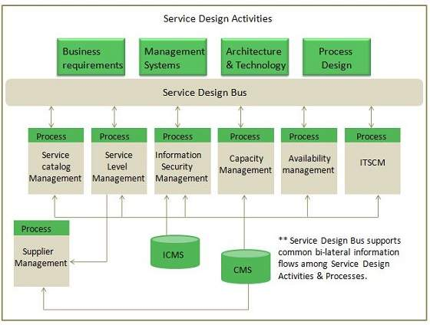

Balanced Deign

It is necessary for services to be adaptable to changing business requirements on dynamic basis. For this a balance must be maintained between following three factors:

* Functionality with the required quality.
* Resources i.e. staff, technologies, and available finances.
* Timetable

Aspects of Service Design

Service Design focuses on the following aspects:

* IT Services designed to meet business objectives.
* Services designed to be both fit for purpose and fit for use.
* Cost of ownership planed to achieve return on investment.
* Balanced functionality, cost and performance.
* IT services more stable and more predictable.
* Potential risk mitigated, so the IT service is protected from security threats.
* Design technology architectures, management architectures, and system management tools.
* Design of the measurement systems, methods, and metrics for services, processes, architectures and underlying components.
* Design of the service solution including all agreed functional requirements, resources and capabilities.

Service Oriented Architecture

**Service Oriented Architecture (SOA)** refers to developing independent usable services. SOA is defined by Organization for the **Advancement of Information Structured (OASIS).** SOA provides more flexibility through modularity.

Prerequisites for SOA approach

Here the prerequisites required for implementation of SOA approach:

* Definition of services
* Clarity regarding interfaces and dependencies between services
* The application of standards for the development and definition of services
* Use of broadly-based technologies and tools.

Service Design Processes

Following table describes several processes in Service Design:

|  |  |  |
| --- | --- | --- |
| **S.N.** | **Process Description** |  |
| 1. | **Design Coordination** It deals with maintaining policies, guidelines, standards, budget for service design activity. |  |
| 2. | **Service Catalogue Management** This process is responsible for designing service catalogue containing service specific to the customer for which they are willing to pay. |  |
| 3. | **Service Level Management** The goal of this process is to ensure quality of the services meet provisioned quality agreements. |  |
| 4. | **Capacity Management** Capacity Management ensures optimal and economic usage of existing resources and future capacity requirement planning. |  |
| 5. | **Availability Management** Availability Management ensures the operative services meet all agreed availability goals. |  |
| 6. | **IT Service Continuity Management** This process ensures continuity of IT services regardless of any disaster occurs. |  |
| 7. | **Information Security Management** This process ensures confidentiality, integrity, availability of data. |  |
| 8. | **Supplier Management** This process ensures supplier relationship & performance and also ensures management of right and relevant contracts with supplier. |  |

# Service Catalogue Management

[Previous Page](http://www.tutorialspoint.com/itil/service_design_overview.htm)

[Next Page](http://www.tutorialspoint.com/itil/service_level_management.htm)

Service Catalogue

Service Catalogue contains information of specific services for which customer are willing to pay. It is a knowledge management tool which allows employees and consultants to route their request for and about services.

Service catalogue is subset of service portfolio and contains presently active services in service operation phase.

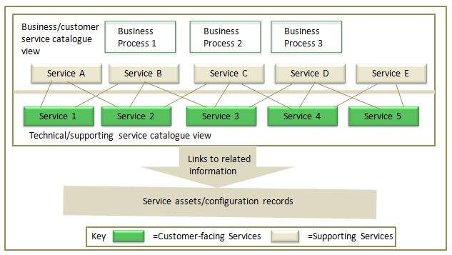

Service Catalogue Composition

Each service in the catalogue contains the following elements:

* A identification label for the service
* Description of services
* Related service request types
* Any supporting or underpinning services
* Service categorization or type that allows it to be grouped with other similar services
* Interfaces and dependencies between all services, and supporting components and configuration items (CIs) within the service catalogue and the CMS
* Clear ownership of and accountability for the service
* Associated costs
* How to request the service and how its delivery is fulfilled
* Escalation points and key contracts
* Service level agreement (SLA) data

Service Catalogue Aspects

Service catalogue has two aspects:

Business Service Catalogue

It contains all the IT services delivered to the customer, together with their relationship to the business units and the business process that rely on the IT services.

Technical Service Catalogue

It contains all the IT services delivered to the customer, together with their relationship with supporting services, shared services, components, and CIs necessary to support the provision of the service to the business.

Service catalogue management process is responsible for providing information regarding all agreed services to all authorized persons. This process also takes care of creation and maintenance of service catalogue with correct and updated information.

Service Catalogue Manager is the process owner of this process.

Any change to service portfolio or service catalogue is subject to Change Management process.

SCM Activities

Here are the key activities included in Service Catalogue Management:

* Agreeing and documenting a service definition with all relevant parties
* Interfacing and Service Portfolio Management to agree the contents of the Service Portfolio Management to agree the contents of the Service Portfolio and Service catalogue
* Interfacing with the business and IT Service Continuity Management on the dependencies of business units and their business processes with the supporting IT services contained within the Business Service Catalogue
* Producing and maintaining a Service Catalogue and its contents, in conjunction with service portfolio
* Interfacing with Business Relationship Management and Service Level Management to ensure that the information is aligned to the business and business process.

# Service Level Management

[Previous Page](http://www.tutorialspoint.com/itil/service_catalogue_management.htm)

[Next Page](http://www.tutorialspoint.com/itil/capacity_management.htm)

Overview

**Service Level Management (SLM)** deals with negotiating, agreeing and documenting existing services with some level of policies.

Service Level Manager is the process owner of this process.

SLM deals with following two kinds of agreements:

1. Service Level Agreement (SLA)
2. Operational Level Agreement (OLA)

Service Level Agreement (SLA)

It is agreed document assuring the warranty with regard to level of service quality delivered by the service provider. It is between service provider and the customer.

Operational Level Agreement (OLA)

Unlike SLA it is agreement within the organization.

SLM Activities

The following diagram describes activities involved in SLM process:

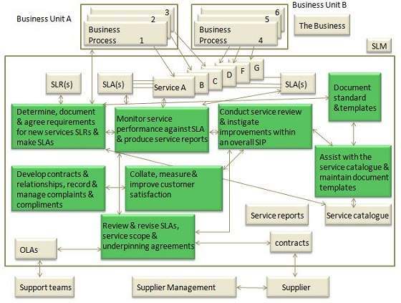

Service Level Requirement (SLR) is one of the earliest activities in Service design of Service Lifecycle. SLR needs to be drafted, once the service catalogue has been produced and SLA structure has been agreed

Objectives

Here are the objectives of SLM:

|  |  |
| --- | --- |
| **S.N.** | **Objectives** |
| 1. | Define, document, agree, monitor, measure, report, and review the level of IT service provided. |
| 2. | Provide and improve the relationship and communication with the business and customers. |
| 3. | Ensure that specific and measurable targets are developed for all IT services. |
| 4. | Monitor and improve customer satisfaction with the quality of service delivered |
| 5. | Ensure that IT and customers have a clear and unambiguous expectation of the level of service to be delivered |

Capacity Management

[Previous Page](http://www.tutorialspoint.com/itil/service_level_management.htm)

[Next Page](http://www.tutorialspoint.com/itil/availability_management.htm)

**Capacity Management** ensures proper utilization of available resources and makes future capacity requirement available in cost-effective and timely manner. Capacity Management is considered during Service Strategy and Service Design phases.

It also ensures that IT is sized in optimum and cost-effective manner by producing and regularly upgrading capacity plan.

Capacity Manager is the process owner of this process.

Capacity Management Activities

The following table describes several activities involved in Capacity Management Process:

|  |  |
| --- | --- |
| **S.N.** | **Capacity Management Activities** |
| 1. | Producing capacity plans, enabling service provider to continue to provide services of quality defined in SLA. |
| 2. | Assistance with identification and resolution of any incident associated with any service or component performance. |
| 3. | Understanding customer’s current and future demands for IT resources and producing forecasts for future requirements |
| 4. | Monitoring Pattern of Business activity and service level plans through performance, utilization and throughput of IT services and the supporting infrastructure, environmental, data and applications components. |
| 5. | Influencing demand management in conjunction with Financial Management |
| 6. | Undertaking tuning activities to make the most efficient use of existing IT resources. |
| 7. | Proactive improvement of service or component performance |

Objectives

Here are the several objectives of Capacity Management:

|  |  |
| --- | --- |
| **S.N.** | **Objectives** |
| 1. | Produce and maintain an appropriate up-to-date capacity plan reflecting the current and future needs of the business. |
| 2. | Provide advice and guidance to all other areas of the business and IT on all capacity and performance related issues. |
| 3. | To manage performance and capacity of both services and resources. |
| 4. | Assisting with diagnosis and resolution of performance and capacity related incidents and problems. |
| 5. | Assess the impact of all changes on the capacity plan, and the performance and capacity of services and resources. |
| 6. | Ensure that proactive measures to improve the performance of services are implemented wherever it is cost justifiable to do so. |

Capacity Management Elements

Capacity Management broadly includes three components: **Business capacity management, Service capacity management,** and **Component capacity management** as shown in the following diagram:

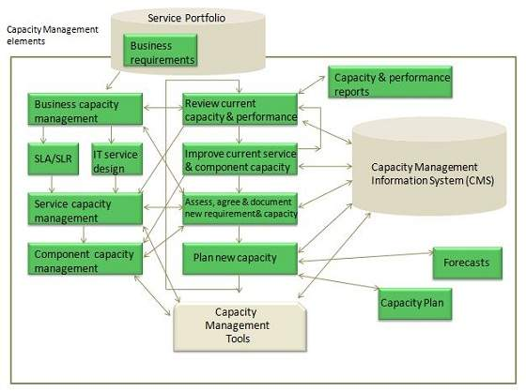

Business Capacity Management

This sub-process deals with forecasting and developing plans for future business needs. It is done by using existing data on current resource utilization by various services.

Service Capacity Management

This sub-process deals with understanding the functioning of IT service, resource usage and variation to ensure that appropriate service agreement can be designed.

Component Capacity Management

This sub-process ensures optimizing use of current IT resource components such as network capacity, bandwidth etc.

Capacity Management Information System (CMIS)

CMIS maintains updated database of resources, commodities etc. which is used by all sub-processes within Capacity management.

# Availability Management

[Previous Page](http://www.tutorialspoint.com/itil/capacity_management.htm)

[Next Page](http://www.tutorialspoint.com/itil/service_continuity_management.htm)

**Availability Management (AM)** ensures that IT services meet agreed availability goals. It also ensures new or changed service meet availability goals and doesn’t affect the existing services.

Availability is expressed as:

**(Agreed service time – Down time)/Agreed Service Time**

Availability Manager is the process owner of this process.

Objectives

Here are the objectives of Availability Management:

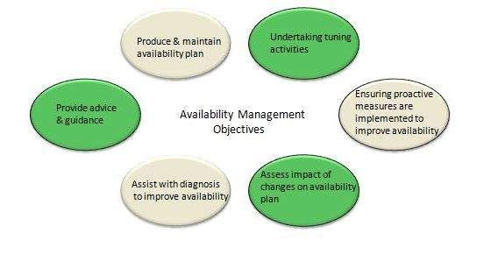

Availability Management Process

Availability Management process is comprises of following key elements:

* Reactive activities
* Proactive activities

Reactive activities

Activities that are involved in operational roles are known as reactive activities. Activities such as monitoring, measuring, analysis and management of all events, incidents and problem involving unavailability come under reactive activities.

Proactive activities

Activities that are involved in design and planning roles are known as proactive activities. Activities such as proactive planning, design & improvement of availability come under proactive activities.

Availability Management process is completed at following two interconnected levels:

* Service availability
* Component availability

Service availability

It deals with availability and unavailability of service and also the impact of component availability and unavailability on service availability.

Component availability

It deals with component availability and unavailability.

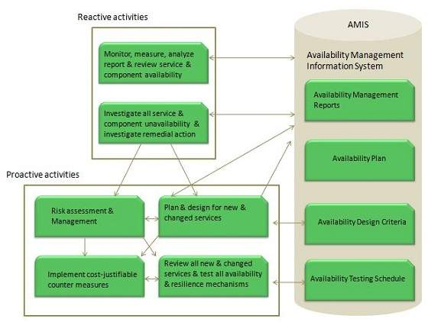

Availability Management sub-processes

The following diagram shows sub-processes involved in Availability Management process:

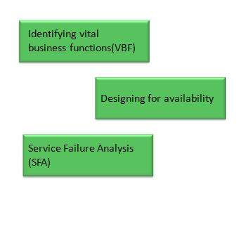

Identifying vital business function (VBF)

VBF refers to business-critical elements that are supported by an IT service. It is important to document all VBFs to provide better business alignment and focus.

Designing for availability

Although additional costs are incurred in providing high availability solution to meet stringent high availability needs yet it is necessary to provide high availability of those services supporting to more critical VBFs.

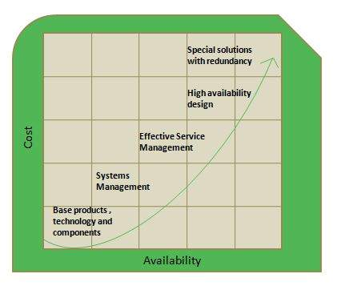

Service Failure Analysis (SFA)

Service Failure Analysis is designed to:

* Provide structured approach to identifying causes of service interruption to the user.
* Assess where and why shortfalls in availability are occurring.
* Improve overall availability of IT services by producing a set of improvement for implementation or input to Activity Plan.
* Service Continuity Management
* [Previous Page](http://www.tutorialspoint.com/itil/availability_management.htm)
* [Next Page](http://www.tutorialspoint.com/itil/information_security_management.htm)
* **ITSCM** ensures continuity of IT service in time of any disaster. It also evaluates the level of insurance we need to protect service assets and a manuscript to recover from a disaster.
* IT Service Continuity Manager is the process owner of this process.
* Objective
* The following diagram shows the several objectives of ITSCM:
* 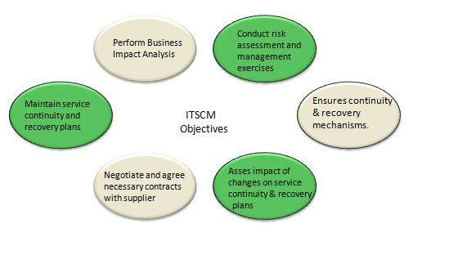
* ITSCM Process
* ITSCM process comprises of four stages: **Initiation, Requirements & strategy, Implementation,** and **Ongoing operation.**
* 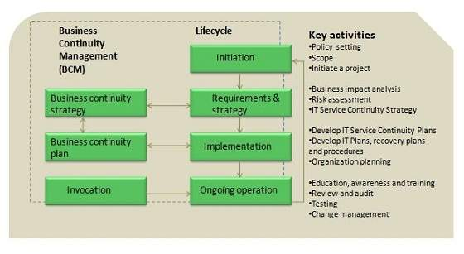
* Initiation
* It includes policy setting defining scope and terms of reference, project planning and resource allocation.
* Requirements and strategy
* It includes business impact analysis, risk assessment.
* Implementation
* It includes executing risk reduction measures, recovery option arrangements, testing and plans.
* Ongoing operation
* It includes education and awareness, change control of ITSCM plans, ongoing testing.

# Information Security Management

[Previous Page](http://www.tutorialspoint.com/itil/service_continuity_management.htm)

[Next Page](http://www.tutorialspoint.com/itil/supplier_management.htm)

**Information Security Management (ISM)** ensures confidentiality, authenticity, non-repudiation, integrity, and availability of organization data and IT services. It also ensures reasonable use of organization’s information resources and appropriate management of information security risks.

Information Security Manager is the process owner of this process.

Information security is considered to be met when:

* Information is observed or disclosed on only authorized persons
* Information is complete, accurate and protected against unauthorized access (integrity)
* Information is available and usable when required, and the systems providing the information resist attack and recover from or prevent failures (availability)
* Business transaction as well information exchanges between enterprises, or with partners, can be trusted (authenticity and non-repudiation)

ISM Security Policy

It is required for ISM security policies cover all areas of security, be appropriate, meet the needs of business and should include the policies shown in the following diagram:

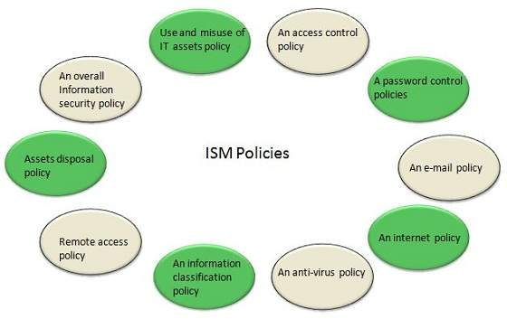

ISM Framework

ISM Process

The following diagram shows the entire process of Information Security Management (ISM):

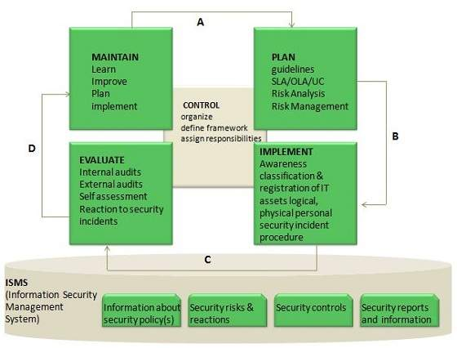

Key elements in ISM Framework

ISM framework involves the following key elements:

**Control**

The objective of Control element is to:

* Establish an organization structure to prepare, approve and implement the information security policy
* Allocate responsibilities
* Establish and control documentation

**Plan**

The purpose of this element is to devise and recommend the appropriate security measures, based on an understanding of the requirements of the organization.

**Implement**

This key element ensures that appropriate procedures, tools and controls are in place to underpin the security policy.

**Evaluation**

The objective of Evaluation element is to:

* Carry out regular audits of the technical security of IT systems
* Supervise and check compliance with security policy and security requirements in SLAs and OLAs

**Maintain**

The objective of Maintain element is to:

* Improve on security agreements as specified in, for example, SLAs and OLAs
* Improve the implementation of security measures and controls

**Preventive**

This key element ensures prevention from security incidents to occur. Measures such as control of access rights, authorization, identification, and authentication and access control are required for this preventive security measures to be effective.

**Reductive**

It deals with minimizing any possible damage that may occur.

**Detective**

It is important to detect any security incident as soon as possible.

**Repressive**

This measure is used to counteract any repetition of security incident.

**Corrective**

This measure ensures damage is repaired as far as possible.

# Supplier Management

[Previous Page](http://www.tutorialspoint.com/itil/information_security_management.htm)

[Next Page](http://www.tutorialspoint.com/itil/service_transition_overview.htm)

Supplier Management deals with maintaining good relationship between suppliers and the partners to ensure quality IT services.

Supplier Manager is the process owner of this process.

Objectives

The following diagram shows several objectives of supplier management:

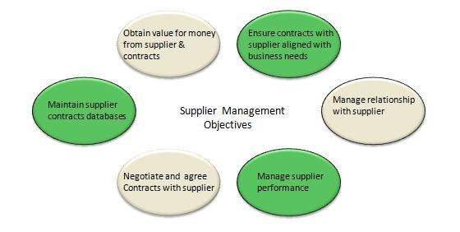

Supplier Management Process

The following diagram shows several activities included in Supplier Management:

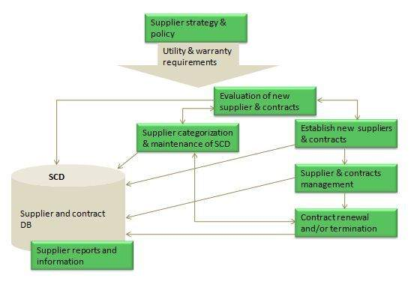

Here are the activities involved in Supplier Management Process:

* Implantation and enforcement of the supplier policy
* Maintenance of an SCD
* Supplier and contract evaluation and selection
* Supplier and contract categorization and risk assessment
* Contract review, renewal and termination
* Development, negotiation and agreement of contracts
* Maintenance of standard contracts, terms and conditions
* Management of contractual dispute resolution
* Management of sub-contracted suppliers
* Agreement and implementation of service and supplier improvement plans

# Service Transition Overview

[Previous Page](http://www.tutorialspoint.com/itil/supplier_management.htm)

[Next Page](http://www.tutorialspoint.com/itil/project_management.htm)

**Service Transition** manages transition of a new or changed service. It ensures all changes to the service management processes are carried out in coordinated way.

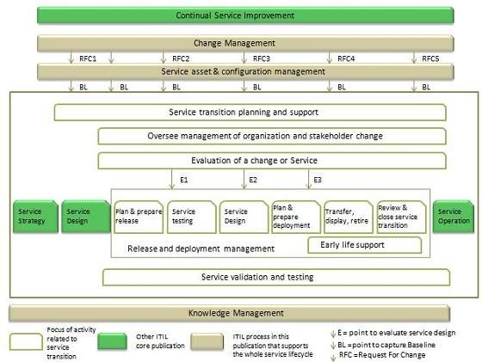

Objectives

Here are the several objective of Service Transition:

|  |  |
| --- | --- |
| **S.N.** | **Objectives** |
| 1. | Provide a consistent framework for evaluating the service capability and risk profile before a new or changed service is released or deployed. |
| 2. | Establish and maintain the integrity of all identified service assets and configurations as they evolve through the service transition stage. |
| 3. | Plan and manage the capacity and resources required to package, build, test, and deploy a release in to production and establish the service specified in the customer and stakeholder requirements. |
| 4. | Provide efficient repeatable build and installation mechanisms that can be used to deploy releases to the test and production environments and be rebuilt if required to restore service. |
| 5. | Ensure that service can be managed, operated and supported in accordance with the requirements and constraints specified in service design. |

Service Transition Benefits

Service Transition helps to improve several things as discussed below:

* Quick adaptability to new requirements
* Transition management of mergers, de-mergers, acquisitions and transfer of services
* Success rate of changes and releases for the business
* Success rate of changes and releases for the business
* Predictions of service levels and warranties for new and changed service
* Confidence in the degree of compliance with business and governance requirements during change
* Variation of actual against estimated and improved plans and budgets
* Productivity of business customer staff
* Timely cancellation or changes to maintenance contracts for software and hardware when components are decommissioned.
* Understanding the level of risk during and after change

Service Transition Processes

Here are the processes involved in Service Transition:

|  |  |
| --- | --- |
| **S.N.** | **Process Description** |
| 1. | **Transition Planning and Support** This process deals with management and control of transition plan. |
| 2. | **Change Management** This process ensures manage and control change management process. It also prevents any unauthorized change to occur. |
| 3. | **Service Asset and Configuration Management (SACM)** It maintains database for configuration items such as servers, switches, routers etc. |
| 4. | **Release and Deployment Management** This process deals with management and control of movement of releases to test and live environment. |
| 5. | **Service validation and Testing** This process deals with the quality of services offered. |
| 6. | **Knowledge Management** This process deals with gathering, storing, analyzing, and sharing knowledge. |

# Project Management

[Previous Page](http://www.tutorialspoint.com/itil/service_transition_overview.htm)

[Next Page](http://www.tutorialspoint.com/itil/change_management.htm)

**Transition Planning and support (Project management)** deals with planning the resources to deploy major release within predicted cost, time and quality estimates.

Project manager is the process owner of this process.

Objectives

The following diagram describes the several objectives of project management process:

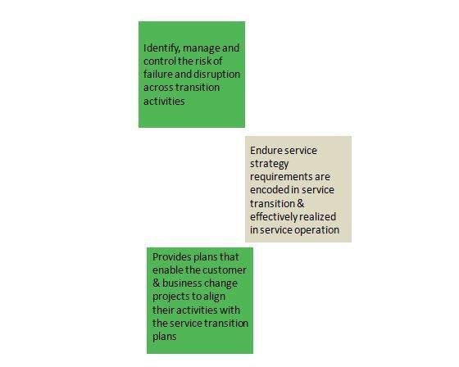

The Service Transition Strategy considers several aspects to organize Service Transition and allocating resources:

* Purpose, goals, and objectives of Service Transition
* Framework for Service Transition
* Context, e.g. service customers, contract portfolios
* Criteria
* Organizations and stakeholders involved in transition
* People
* Approach
* Schedule for milestones
* Financial requirements

Planning an individual Service Transition

Service Transition plans describe tasks and activities required to release and deploy a release in to the test environment. It is good practice to deploy Service Transition plan from a proven Service Transition model.

Service Transition Plan also includes:

* Issues and risks to be managed
* Activities and tasks to be performed
* Schedules of milestones, handover and delivery dates
* Staffing, resource requirements, budgets, and timescales at each stage
* Lead times and contingency

Key Points:

* It is required to have integrated transition plans that are linked to lower level plans such as release, build and test plans.
* It is best practice to manage several releases and deployments as a programme, with each deployment run as a project.

Reviewing the Plans

It is required to verify the plans as and ask following questions before starting release or deployment:

* Have the plans been agreed and authorized by all relevant parties, e.g. customers, users, operations and support staff?
* Do the plans include the release dates, and deliverables, and refer to related change requests, known errors and problems?
* Has the service Design altered significantly such that it is no longer appropriate?
* Have potential changes in business circumstances been identified?
* Do the people who need to use it understand and have the required skills to use it?
* Have the impacts on cost, organizational, technical and commercial aspects been considered?
* Have the risk to overall services and operation capability been assessed?
* Is the service release within the SDP and scope of what the transition model addresses?

# Change Management

[Previous Page](http://www.tutorialspoint.com/itil/project_management.htm)

[Next Page](http://www.tutorialspoint.com/itil/assets_and_configuration_management.htm)

Introduction

**Change** in IT service refers to commissioning, decommissioning or up gradation of configuration of servers.

All changes are required to be implemented with minimum disruption of IT services.

Change Management process deals with following aspects while implementing a change:

* Study the adverse impact of change and minimize it
* Create and maintain change management process
* Prevent unauthorized changes in the environment
* Maintain record of all the changes
* Post implementation review of all changes

Change is not implemented by change management team rather it is implemented by a technical team. Change management team only review and approve the change.

Change Manager is the process owner of this process.

**Key Points:**

* Change manager is the person who approves the changes and closes it. He also checks whether it meets the desired result.
* Change coordinator raises changes
* Change coordinator has to send screen shots after the change in **Post Implementation Report (PIR)**

Objectives

Following are the several objectives of change management process:

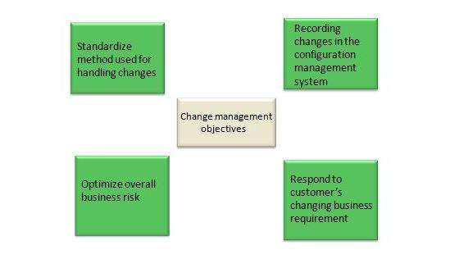

Seven Rs of Change Management

These are the seven questions that must be answered for all changes. It helps to assess impact of changes and risk and benefit to the service.

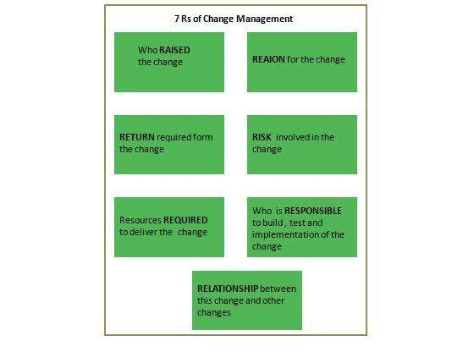

Request For Change (RFC) is the key information source and the catalyst for the change activities of:• Create and record

* Review
* Assess and evaluate
* Authorize
* Plan
* Coordinate
* Review
* Close

Each RFC will follow a certain change model that is suitable for the nature and type of change.

Change Models

There are basically three change models as listed below:

* Standard change Model
* Normal change Model
* Emergency change Model

Standard change model

This model is used for pre-authorized repetitive, low risk and well tested changes.

Normal change model

In this model any change must go through certain steps such as assessment, authorization, and Change Advisory Board (CAB) agreement before implementation.

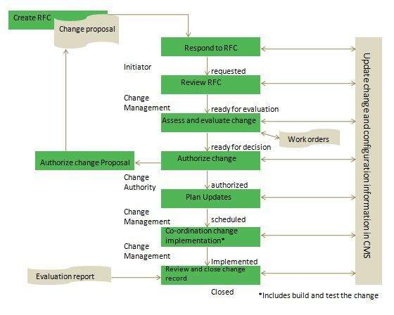

Emergency change model

This change model deals with highly critical changes needed to restore failed high availability service failure.

Change Advisory Board (CAB) is a body to authorize the changes and assist change management in assessing and prioritization the changes.

# Service Assets and Configuration Management

[Previous Page](http://www.tutorialspoint.com/itil/change_management.htm)

[Next Page](http://www.tutorialspoint.com/itil/release_and_deployment_management.htm)

Overview

Assets

**Asset** is something that has financial value with a depreciation rate attached to it. It has a cost and organization uses it for its asset value calculation.

It doesn’t have direct impact on delivering services. Anything such as servers, buildings, blackberries, switches, routers etc. comes under assets.

Configuration Items (CIs)

**Configuration item** is subset of service assets and have direct impact on delivering services. All servers, networks, applications that have impact on production are known as configuration item.

Building is an asset but not CI. Document is a CI not an asset.

Hence **Service Assets and Configuration Management (SACM)** deals with maintaining up-to-date and verified database of all assets and CIs which are also made available to other service management processes.

* Configuration Manager is the process owner of this process.
* SACM uses Configuration Management System (CMS) which contains one or more Configuration Management Databases (CMDB).

CIs Types

CIs are categorized into six as shown in the following diagram:

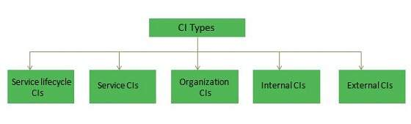

**Service Lifecycle CIs**

Service lifecycle CIs gives clear picture on:

* Services
* How services will be delivered?
* What benefits are expected?
* Service cost

**Service CIs**

Service CIs refers to:

* Service model
* Service package
* Release package
* Service resource assets
* Service capability assets

**Organization CIs**

Organization CIs are internal to an organization but independent of the service provider.

**Internal CIs**

CIs which are delivered by individual projects are known as Internal CIs.

**External CIs**

External CIs refer to external customer requirements and agreements, releases from supplier and external services.

**Interface CIs**

These CIs are required to deliver end-to-end service across a Service Provider Interface (SPI).

Configuration Management System (CMS)

**SACM** uses **Configuration Management System (CMS)** which contains one or more **Configuration Management Databases (CMDB).** The database contains information associated with a CI such as supplier, cost, purchase date, renewal date for licenses and maintenance contracts and other related documents such as SLA etc.

There are also other attributes for Configuration Items such as:

* Unique Identifier
* CI type
* Name/description
* Supply date
* Location
* Status
* License details
* Related document masters
* Related software masters
* Historical data
* Relationship type
* Application SLA

Service Assets and Configuration Process

SACM process comprises of following five activities:

1. Management and Planning
2. Configuration identification
3. Configuration control
4. Status accounting and reporting
5. Verification and Audit

All of the above mentioned activities are described in the following diagram:

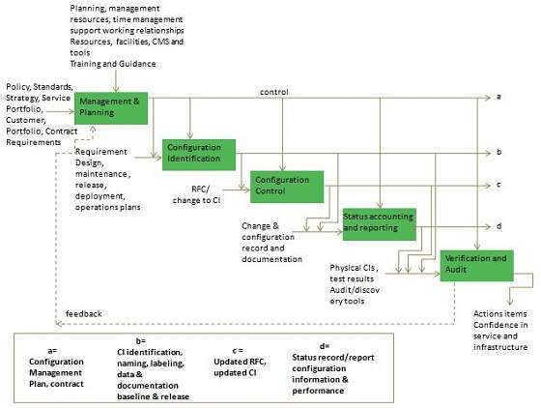

# Release and Deployment Management

[Previous Page](http://www.tutorialspoint.com/itil/assets_and_configuration_management.htm)

[Next Page](http://www.tutorialspoint.com/itil/validation_and_testing.htm)

**Release and Deployment Management** includes planning, designing, building, testing and deploying new software and hardware components in the live environment. It is important to maintain integrity of live environment by deploying correct releases.

Release Manager is the process owner of this process.

**Key Points:**

* Release Unit refers to portion of IT infrastructure that should be released together.
* In Release package each of the software in the package depends on other software in the group for its performance.

Objectives

Release and Deployment management ensures that:

* Delivering change faster and at optimum cost and minimized risk
* Successful and on schedule deployment of release package.
* New or changed services are capable of delivering the agreed service requirements.
* There is knowledge transfer to enable the customers and users to optimize their use of service to support their business activities.
* Minimal unpredicted impact on the production services, operation and support organization.
* Customers, users and service management staff are satisfied with service transition practices and outputs.

It is important to define appropriate release package type for a given type of release. The following diagram illustrates an example of a release package:

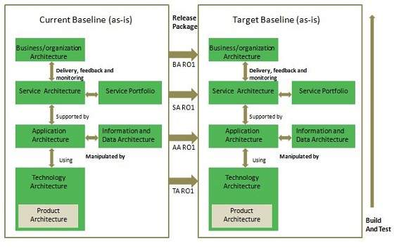

Release and Deployment Management Process

Here the activities included in Release and Deployment Management process:

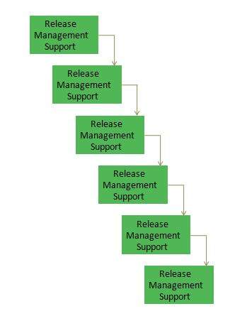

Release Management Support

It provides guidelines and support for the deployment of releases.

Release Planning

The objective of this process is to assign authorized changes to release packages. It also defines the scope of releases.

Release Build

This process deals with building releases and ensures all components are ready to enter the testing phase.

Release Deployment

The objective of this process is to deploy new release in the live environment and also arrange training for end users and operating staff.

Early Life Support

The purpose of this process is to resolve operational issues during initial period after release deployment.

Release Closure

This process deals with closing a release after verifying if activity logs and CMS contents are up to date.

Service and Validation Testing

[Previous Page](http://www.tutorialspoint.com/itil/release_and_deployment_management.htm)

[Next Page](http://www.tutorialspoint.com/itil/knowledge_management.htm)

Overview

It is necessary to actively maintain test environments to ensure that the deployed releases meet the customer’s expectations, and to verify that IT operations are able to support the new services.

Test Manager is the process owner of this process.

The following diagram describes an example of service testing through the Service Transition stage of the lifecycle:

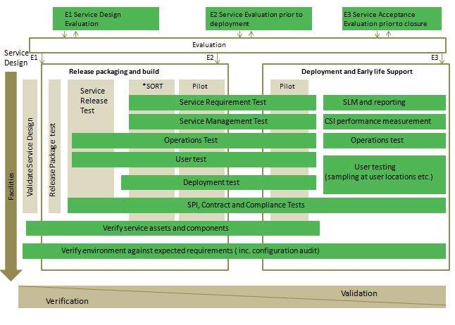

Knowledge Management

[Previous Page](http://www.tutorialspoint.com/itil/validation_and_testing.htm)

[Next Page](http://www.tutorialspoint.com/itil/service_operation_overview.htm)

**Knowledge Management** deals with gathering, storing, analyzing and sharing the knowledge within an organization. It helps to improve efficiency by reducing the need to rediscover knowledge.

Knowledge Manager is the process owner of this process.

Objectives

The following diagram describes the several objectives of knowledge management process:

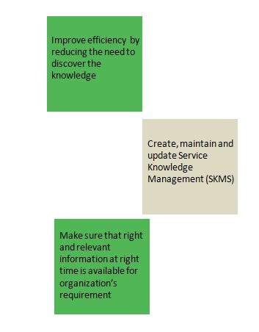

Knowledge Management is a central process that receives input from all other processes and responsible for providing knowledge to service management processes as shown in the following diagram.

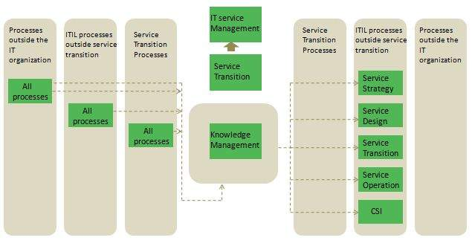

Service Knowledge Management System (SKMS) is a central repository of data, information, and knowledge that the IT organization needs to manage lifecycle of its services.

# Service Operation Overview

[Previous Page](http://www.tutorialspoint.com/itil/knowledge_management.htm)

[Next Page](http://www.tutorialspoint.com/itil/event_management.htm)

**Service operation**ensures that services are being provided efficiently and effectively as per SLAs. It includes monitoring services, resolving incidents, fulfilling requests and carrying out operational tasks.

**Key Points:**

* Service Operation includes five process and four functions
* Service operation deals with day-to-day activities and infrastructure that are being used to deliver the services
* Service Operations is where all design and transition plans are executed and measured
* From customer point of view, Service Operation is where actual value is seen

Service Operation Processes

Service operations include total five processes as described in the following table:

|  |  |
| --- | --- |
| **S.N.** | **Process Description** |
| 1. | **Event Management** The objective of this process is to make sure all CIs are monitored constantly. It also filter and categorize the events in order to decide on appropriate actions. |
| 2. | **Incident Management** The purpose of Incident Management is to restore the service to the previous stage as early as possible. |
| 3. | **Request Fulfillment** This process deals with handling requests such as change password, create new user and create email id etc. |
| 4. | **Access Management** This process deals with granting rights to authorized user to use the service. |
| 5. | **Problem Management** This process deals with finding root cause of the problem and prevent incident to occur again. |

Service Operation Functions

Service Operation comprises of four functions as shown in the following diagram:

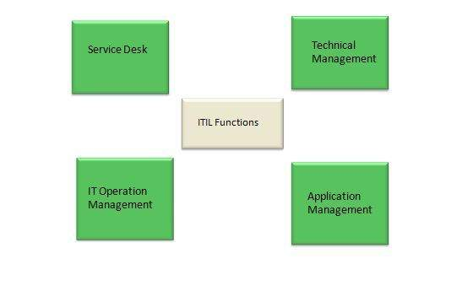

Service Desk

Service Desk is the first and single point of contact. It plays vital role in customer satisfaction. It coordinates activities between end user and IT service provider team. It also own the logged requests and ensures closure of these requests.

There are four types of Service Desk:

**Central Service Desk**

In this, there is only one central Service Desk.

**Local or distributed Service Desk**

It is costly but closer to the user. It’s difficult to manage and maintain.

**Virtual Service Desk**

It is very costly and result in fast processing.

**Specialized Service Desk**

It includes dedicated skilled staff for specific queries.

IT Operation Management

This function is responsible for managing organization’s day-to-day operational activities

Technical Management

Technical Management staff includes technical expertises that are responsible for management of overall IT infrastructure.

Application Management

Application Management is responsible for managing applications and software throughout the lifecycle of the service.

# Event Management

[Previous Page](http://www.tutorialspoint.com/itil/service_operation_overview.htm)

[Next Page](http://www.tutorialspoint.com/itil/incident_and_request.htm)

Overview

Event is defined as detectable occurrence that has significance for the delivery of IT service. Events are created by Configuration Item (CI) or the monitoring tools.

**Event Management** ensures that all CIs are constantly monitored and define a process to categorize these events so that appropriate action can be taken if required.

IT Operation Manager is the process owner of this process.

Event Management can be applied on the following aspects:

* Configuration Items (CIs)
* Security
* Environment Conditions ( e.g. fire and smoke detections)
* Normal activity (e.g. tracking the use of an application or performance of a server)
* Software licence monitoring for usage to ensure legal licence utilization and allocation

There are two types of monitoring tools as described below:

* Active monitoring tools monitor CIs for their status and availability. Any deviation from normal operation is communicated the appropriate team for action
* Passive monitoring tools detect and correlate operational alerts or communications generated by CIs.

Event Management Process

The Event Management Process is self descriptive as shown in the following diagram:

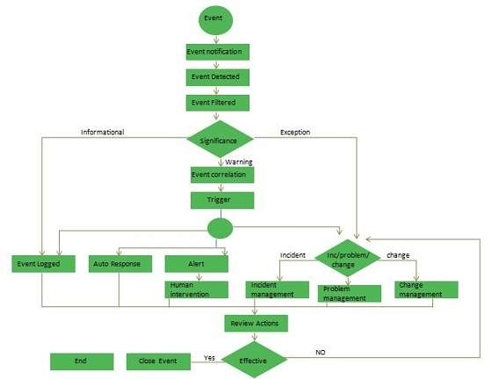

Benefits

Here are the several benefits of Event Management:

* It helps to detect incidents at early stage. Thus incident can be assigned to appropriate team before any service outage occurs
* It removes need for expensive and resource intensive monitoring
* It can also be applied on some service management processes such as Availability management or capacity management. It automatically generates signal when status changes that allow appropriate team to perform early response
* Since it is automates, hence provides increased efficiency

# Incident Management and Request Fulfillment

[Previous Page](http://www.tutorialspoint.com/itil/event_management.htm)

[Next Page](http://www.tutorialspoint.com/itil/problem_management.htm)

Overview

**Incident** is defined as any disruption in IT service. Incident can be reported either through the Service Desk or through an interface from event management to incident management tools.

**Incident Management** deals with handling incident and ensures to restore IT service soon as possible.

Incident Manager is the process owner of this process.

Incident Models

There are always some incidents which are not new. They may happen again over a period of time. Therefore it is best practice to have pre-defined model to handle such incidents.

An incident models should include:

* Steps that should be taken to handle the incident
* Chronological order these steps should be taken in, with any dependences or co-processing defined
* Responsibilities: who should do what
* Timescales and thresholds for completion of the actions
* Escalation procedures; who should be contacted and when
* Any necessary evidence-preservation activities

Incident Management Process

Following diagram shows several standard steps to be taken when an incident occurs:

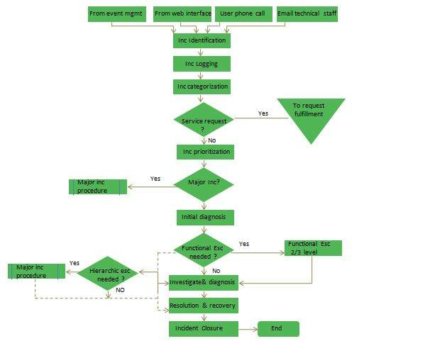

Incident Logging

All incidents should be fully logged and date/time stamped.

Incident Categorization

It is important later when looking at incident types/frequencies to establish trends for use in Problem Management.

Incident Prioritization

It deals with severity of an incident: Low, Medium or High.

Incident Diagnosis

Service Desk analyst must carry out initial diagnosis while the user is on call and try to discover the full symptoms of the incident and to determine exactly what has gone wrong and how to correct it.

Incident Escalation

**Function escalation**

When it becomes clear that Service Desk is unable to resolve the incident or target time for Service Desk has been exceeded, the incident must be escalated immediately for further support.

**Hierarchic escalation**

Hierarchic escalation is done when either incident is serious in nature or ‘Investigation and Diagnosis’ is taking too long time.

Investigation and diagnosis

It includes the following activities:

* Understanding what exactly has gone wrong
* Understanding chronological order of the events
* Confirming the full impact of the incident
* Identifying any events that could have triggered the incident
* Searching for previous similar kind of incidents

Resolution and recovery

A potential resolution need to be identified, applied and tested.

Incident closure

Before closing an incident, Service desk should ask the user whether he is satisfied and agree to close the incident.

Request Fulfilment

Service Request refers to demand by the users. These requests can be regarding small changes, changing the password, installing additional software application, requesting information etc.

Incident is unplanned event but Service Request can be planned.

**Key Points:**

* Depending upon number of Service Requests, an organization usually has, a specialized teams can be formed to fulfil those requests.
* For frequently recurring requests, a predefined model can be devised to fulfil the requests.

# Problem Management

[Previous Page](http://www.tutorialspoint.com/itil/incident_and_request.htm)

[Next Page](http://www.tutorialspoint.com/itil/access_management.htm)

Overview

In ITIL, **Problem** is defined as unknown cause of one or more incident.

**Problem Management** ensures identification of problems and performs Root Cause Analysis. It also ensures that recurring incidents are minimized and problems can be prevented.

Problem Manager is the process owner of this process.

**Key Points:**

* Problem Management comprises of activities required to diagnose the root cause of the incident and to determine the resolution to those problems
* When a problem is resolved after root cause analysis, it becomes known error
* Problem Management also records information regarding problems in a system called **Known Error Database (KED)**

Problem Management consists of following two processes:

* Reactive Problem Management is executed as part of service operation
* Proactive Problem Management initiated in service operation but generally driven as part of Continual Service Improvement

Problem Management Process

The following diagram describes activities involved in Problem Management:

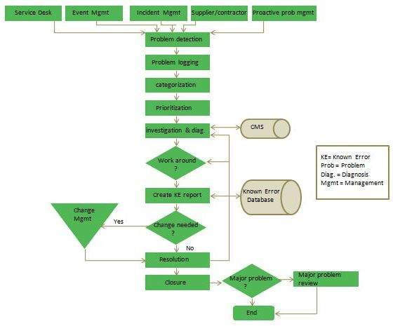

Problem detection

Problem can be detected in following ways:

* Analysis of incident by technical support group
* Automated detection of an infrastructure or application fault, using alert tools automatically to raise an incident which may reveal the need for problem management
* A notification from supplier that a problem exists that has to be resolved

Problem logging

Problem should be fully logged and contains the following details:

* User details
* Service details
* Equipment details
* Priority and categorization details
* Date/time initially logged

Problem categorization

In order to trace true nature of Problem, It is must to categorize the Problems in same way as Incidents.

Problem Prioritization

Problems must be categorized in the same way as incidents to identify how serious the Problem is from an infrastructure perspective.

Workarounds

It is temporary way to overcome the difficulties. Details of workaround should always be documented within Problem record.

Raising a Known Error Record

Known error must be raised and placed in Known Error Database for future reference.

Problem Resolution

Once resolution is found, it must be applied and documented with the problem details.

Problem closure

At time of closure, a check should be performed to ensure that record contains full historical descriptions of all events.

Major Problem Review

A review of following things should be made:

* Those things that were done correctly
* Those things that were done wrong
* What could be done better in future
* How to prevent recurrence

# Access Management

[Previous Page](http://www.tutorialspoint.com/itil/problem_management.htm)

[Next Page](http://www.tutorialspoint.com/itil/csi_overview.htm)

Overview

**Access Management** deals with granting access to authorized access while preventing access to non-authorized users.

Access Manager is the process owner of this process.

**Key Points:**

* Access Management is also known as ‘rights management’ or ‘identity management’
* Access Management process is executed by technical and application management functions.
* Access Management can be initiated by Service Request through Service Desk

Value to business

Access Management adds value to business in following ways:

* Employees have right level of access to execute their jobs effectively
* The ability to audit use of services and to trace the abuse of services
* Controlled access to services ensures that organization is able to maintain more effectively the confidentiality of its information

Access Management Process

Activates involved in Access Management are self explanatory as shown in the following diagram:

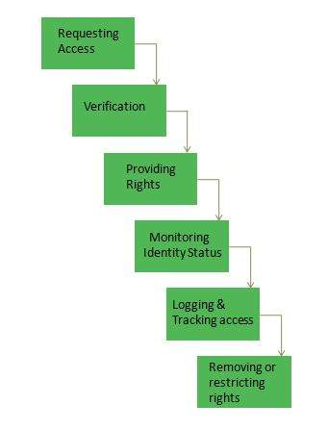

# CSI Overview

[Previous Page](http://www.tutorialspoint.com/itil/access_management.htm)

[Next Page](http://www.tutorialspoint.com/itil/service_reporting.htm)

**Continuous Service Improvement (CSI)** deals with measures to be taken to improve the quality of services by learning from past successes and failures. Its purpose is to align and realign IT Services to the changing needs by identifying and implementing improvements to the changing business needs.

Objectives

Here are the serveral objectives of Continual Service Improvement:

* Review and analyze improvement opportunities in each lifecycle phase
* Review and analyze Service Level achievement results
* Improve cost effectiveness of delivering IT services without sacrificing customer satisfaction
* Identify and implement individual activities to improve IT service quality
* Ensures applicable quality management methods are used to support continual improvement activities

Activities Supporting CSI

The activities that support CSI do not happen automatically and thus required to be owned within IT organization which is capable of handling the responsibilities and processes the appropriate authority to make things happen. Here are the activities supporting Continual Service Improvement:

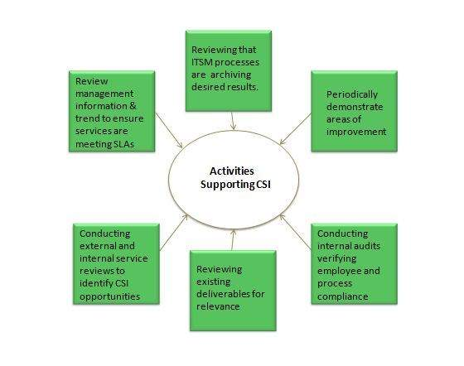

CSI Process Model

The steps involved in CSI are self explanatory as described in the following diagram:

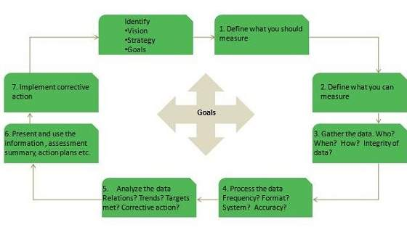

Perspectives of Benefits

Here are the four perspectives of benefits that are taken into consideration while discussing outcomes of CSI:

Improvement

This is comparison of result of current state of service to previous.

Benefits

It is the gain achieved through realization of improvements.

Return on Investment

It is the difference between benefits and amount expanded to achieve that benefit.

Value on Investment

It is the extra value created by establishment of benefits that include non-monetary or long-term outcomes.

Service Reporting

[Previous Page](http://www.tutorialspoint.com/itil/csi_overview.htm)

[Next Page](http://www.tutorialspoint.com/itil/interview.htm)

**Service Reporting deals with producing and delivering reports of achievements and trends against Service Levels.**

It is best practice to generate reports as per agreed format, content and frequency with the customers.

The following diagram describes the overall flow of Service Reporting process:

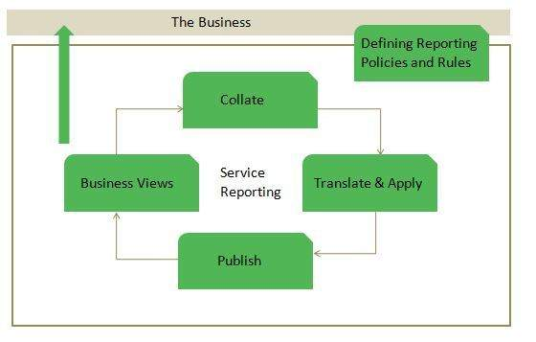

# ITIL - Quick Reference Guide

[Previous Page](http://www.tutorialspoint.com/itil/interview.htm)

[Next Page](http://www.tutorialspoint.com/itil/itil_useful_resources.htm)

ITIL Overview

**ITIL** is a framework providing best practice guidelines on all aspects of end to end service management. It covers complete spectrum of people, processes, products and use of partners.

Now a day’s ITIL is being practiced by almost every company providing IT services to the customers.

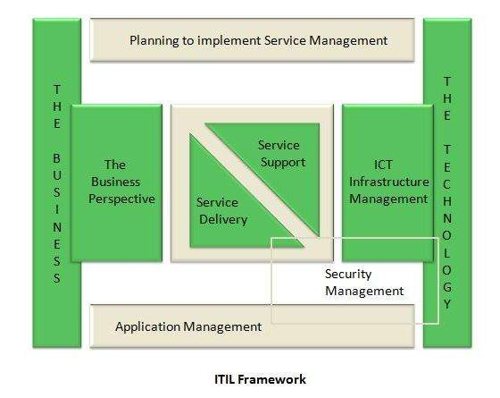

The processes, tasks and checklists described in ITIL are not organization-specific, but can be implemented by any organization. It gives organization a framework to plan, implement and measure IT services.  
ITIL was published in 1989 by **Her Majesty's Stationery Office (HMSO)** in **UK** on behalf of the **Central Communications and Telecommunications Agency (CCTA)**, now subsumed within the Office of Government Commerce (OGC).

Why ITIL is required?

ITIL helps business managers and IT managers to deliver services to the customers in effective manner and hence gaining the customer’s confidence and satisfaction. Here are the areas where ITIL plays an effective role:

* IT and business strategic planning
* Integrating and aligning IT and business goals
* Implementing continuous improvement
* Acquiring and retaining the right resources and skill sets
* Reducing costs and the Total Cost of Ownership
* Demonstrating the business value to IT
* Achieving and demonstrating Value for Money and Return on Investment.
* Measuring IT organization effectiveness and efficiency
* Developing business and IT partnerships and relationships
* Improving project delivery success
* Managing constant business and IT change

ITIL Versions

ITIL was originated as collection of books. These books of ITIL cover all aspects of IT service management. Since its origin, it has undergone many changes which lead to the following versions of ITIL:

* **ITIL V1** was the initial version of ITIL consisting of 31 books
* From 2000 to 2004, **ITIL V1** was revised and replaced by 7 books (ITIL V2). This version became globally accepted and is now used in many countries by thousands of organizations
* In 2007, ITIL v2 was modified and consolidated with 3rd version of ITIL, consisting of five core books covering the service lifecycle. ITIL V3 included **26 processes** and **4 functions**
* In 2011, the 2011 edition of V3 was published. It was an updated version released in 2007.

ITIL Publications

ITIL core publications include a set of five manuals: **Service Strategy, Service Design, Service Transition, Service Operation** and **Continual Service Management.** 

Benefits of ITIL

Following diagram shows several benefits of ITIL:



ITIL V2 vs. ITIL V3

|  |  |  |
| --- | --- | --- |
|  | ITIL V2 | ITIL V3 |
| Focused on product, process and people. | Focused on product, process, people and partner. |  |
| Process oriented approach | Lifecycle based approach. |  |
| Security management is part of evaluation | Security management is a separate process |  |
| Emphasizes on service design and service strategy | Equal attention to all processes |  |
| Have 10 processes and 2 functions | Have 26 processes and 4 functions. |  |

Service Basics

Service

**Service** is a means of delivering value to customers by achieving customer's desired results while working within given constraints.

Services vs. Product

|  |  |  |
| --- | --- | --- |
|  | Services | Products |
| Services are not tangible. | Products are tangible. |  |
| Services are produced and consumed at same time. | Products are not produced and consumed at same time. |  |
| Services are inconsistent. | Products are consistent. |  |
| The user participates in the production of services. | The user doesn’t participate in the production of products. |  |

Service Management

**Service Management** refers to all aspects of the management of IT service provision. According to ITIL, Service management contains all organizational capabilities for generation of added value to the customers as service.

Goals of Service Management

Here are the main goals of Service management:

* Make IT services adaptable towards the present and future requirements of an organization and its customers
* Develop and maintain good & responsive relationship with the business
* Make effective and efficient use of all IT resources
* Optimizing the quality of delivered services
* Reduction of long term cost of service delivery

Achieving Service Management

Here are the key activities needed to be performed in order to achieve business and customer’s satisfaction:

Service Lifecycle

The complete framework of ITIL is based on service lifecycle. Each lifecycle defines certain processes for effective service management.



Service lifecycle helps to amplify the service management approach and to achieve better understanding of its structure. In the coming chapters, we will be discussing all lifecycle individually with their processes and functions.

Processes and Functions

There are 26 processes and 4 functions in ITIL V3. These processes and functions are discussed in detail with each service lifecycle in further chapters.

**Process**

Process defines policies, standards, guidelines, activities, and work instructions. A process takes some defined inputs to produce desired results.

**Functions**

A function is defined as group of people or tools required to carry out one or more processes and activities.

Service Strategy Overview

**Service Strategy** helps to design, develop and implement service management as organizational capabilities and strategic assets as well. It enables a service provider to consistently outperform competitive alternatives over time, across business cycles, industry disruptions and changes in leadership.



Service strategy comprises of the following key concepts:

* Value creation
* Service Assets
* Service Provider types
* Service structures
* Defining the service market
* Developing service offerings
* Financial management
* Service portfolios
* Demand management
* Return on investment

Strategic Assessment

Before crafting service strategy, a provider should first take a careful look at what it does already. The following questions can help expose a service provider’s distinctive capabilities:

* Which or our services or service verities are the most distinctive?
* Which or our services or service verities are the most profitable?
* Which of our activities in our value chain or value network are the most different and effective?

**Factors in Strategic Assessment**

Here are the key factors that play important role in strategic assessment:

|  |  |  |
| --- | --- | --- |
|  | S.N. | Description |
| 1. | **Strengths and weaknesses** The attributes of the organization. For example resources and capabilities, service quality, skills, cost structures, product knowledge, customer relationship etc. |  |
| 2. | **Business Strategy** The perspective, position, plans and patterns are received from a business strategy. |  |
| 3. | **Critical Success factors**How will the service provider know when it is successful? |  |
| 4. | **Threats and opportunities**Includes competitive thinking. For example, is the service provider vulnerable to substitution?, or Is there a means to outperform competing alternatives? |  |

Value Creation

Service strategy defines a unique approach for delivering better value. According to customers service consist of two elements:

* Utility
* Warranty

**Utility**

Utility is perceived by the customer from the attributes of the service that have positive effect on the performance of task associated with the desired business outcomes. This is fir for purpose.

Utility is generally stated in terms of:

* Outcomes supported
* Ownership costs and risks avoided

**Warranty**

Warranty ensures the utility of the service is available as needed with sufficient capacity, continuity, and security. Value of warranty is communicated in terms of level of certainty.

Warranty is usually defined in terms of availability, capacity, continuity, and security of the utilization of the services.

Service Assets

There are two types of service assets as listed below:

* Resources
* Capabilities

**Resources**

Resources are the inputs for production. The resources are transformed by management, organization, people and knowledge.

**Capabilities**

Capabilities refer to skills to develop and control the resources for production. The skills are based on knowledge, experience and information.



Service Provider Types

Service Provider can be broadly classified into three types as described below:

**Type I Internal Service Provider**

Internal Service provider refers to the business functions within an organization. Administration, finance, human resources, and IT service providers all comes under internal service providers.

**Type II Shared Service Provider**

In this, business functions such as IT, human resources, and logistics are consolidated into an autonomous special unit called a Shared Service Unit (SSU).

**Type III External Service Provider**

External service provider refers to the third party service providers. It can offer competitive prices and drive down unit cost by consolidating demand.

The Four Ps of strategy

The below mentioned Four Ps identify the different forms of a service strategy and are considered as entry points to service strategy.



Services strategy processes

The following diagram expresses the different processes and their relationship in service strategy:



Service Strategy Roles

There are several roles that are responsible for managing different key aspects of Service Strategy. Here we will discuss all of the roles in this chapter.

|  |  |  |
| --- | --- | --- |
| **S.N.** | **Role** | **Responsibility** |
| 1. | Business Relationship Manager | * Maintains good relationship with customers * Identifies customer’s needs * Ensures service provider meet customer’s need * Works closely with Service Level Manager |
| 2. | Demand Manager | * Responsible for understanding, anticipating, and influencing customer demand for services * Works with capacity manager to ensure that service provider has sufficient capacity to meet the required demand |
| 3. | Financial Manager | * Responsible for accounting, budgeting, and charging requirements |
| 4. | IT Steering Group (ISG) | * Sets direction and strategy for IT services * Reviews the business and IT strategies in order to make sure that they are aligned * Sets priorities of service development programs |
| 5. | Service Portfolio Manager | * Decides on a strategy to serve customers in cooperation with ISG * Develops service provider’s offering and capabilities |
| 6. | Service Strategy Manager | * Works with ISG in producing and maintaining the service provider’s strategy * Responsible for communicating and implementing service strategy |

Strategy Generation

For positive results, service provider needs to plan his services strategically. A good service strategy defines a unique approach for delivering better value.

Service Strategy Manager is the process owner of this process.

Service Generation Sub processes

Strategy Management comprises of four activities as listed below:

* Defining the market
* Developing offerings
* Developing strategic assets
* Measuring and Preparation for implementation of strategy

**Defining the market**

It is necessary to take survey of services available in the market. It gives a clear perspective of cost and quality of services already present and what new service can be offered in competitive environment.

**Developing offerings**

In this service provider develops a portfolio which contain all the services that are visible and available for the customer. Service portfolio is developed in order to represent all binding service investments towards the market.

**Developing strategic assets**

It deals with buying new technologies, resources and capabilities to offer law-cost and high-value service to the customer.

**Measuring and Preparation for implementation of strategy**

In order to measure success or failure of the strategy, all critical success factors are measured. Also the completion in the market is observed and priorities are

Service Portfolio Management

Service Portfolios

Service portfolio contains description of all the services engaged throughout the service lifecycle. It also represents the commitment and investment made by service provider across all customers and market spaces.



Service catalogue is subset of service portfolio and contains presently active services in service operation phase. We will discuss service catalogue in detail as part of service design process.

**Service portfolio management** ensures that the service provider is offering right combination of services to meet the customer’s need.

Service Portfolio Manager is the process owner of this process.

The purpose of service portfolio management is to provide answer to the following questions:

* Why should customer buy this service?
* Why should they buy from us?
* What form does the pricing structure take?
* What are our strengths and weaknesses, priorities and risks?
* How should we apply our resources and capabilities?

Sub Processes

Service portfolio management includes sub processes as shown in the following diagram:



**Define**

The purpose of this process is to define desired results of a service.

**Analyze**

The purpose of this process is to analyze the impact of proposed new service or changed service on existing services in service portfolio.

**Approve**

The purpose of this process is to submit change proposal to change management and to initiate the design stage for the new or changed service if change proposal is authorized.

**Charter**

The purpose of this process is to communicate decisions, allocate resources and charter services.

Business Relationship Management

Business Relationship Management generally includes:

* Managing personal relationships with managers
* Providing input to Service Portfolio Management
* Ensuring that IT service provider is satisfying the customer’s need

Business Relationship Manager is the process owner of this process.

Sub-Processes

Business Relationship Management includes following sub-processes:

* Maintain Customer Relationship
* Identify Service Requirements
* Sign up customers to Standard Services
* Handle Customer Complaints
* Monitor Customer Complaints
* Customer Satisfaction Survey

**Maintain Customer Relationship**

This process ensures that service provider understands customer’s need and set up relationships with new potential customers.

**Identify Service Requirements**

This process ensures that service provider have complete understanding of output of a service and to decide if the customer’s need can be fulfilled using an existing service offering or if a new service needs to be created.

**Sign up customers to Standard Services**

This process deals with customer requirements and service level agreements.

**Handle Customer Complaints**

The objective of this process is to record customer’s complaints and take corrective action if required.

**Monitor Customer Complaints**

The objective of this process is to monitor the processing status of customer’s complaints.

**Customer Satisfaction Survey**

The objective of this process is to identify the scopes where customer expectations are not being met.

Demand Management

**Demand Management** is very important and critical process in service strategy. It helps to understand customer demand for services so that appropriate capacity can be provisioned to meet those demands.

Improper demand management leads to improper use of services and resources. Hence it’s worth to analyze customer’s demand.

Demand Manager is the process owner of this process.



Stratigical Level Demand Management

Under Stratigical Demand Management we focus on two important things:

* Pattern of Business Analysis
* User Profiles

**Pattern of Business Analysis (PBA)**

**PBA** is an extremely important activity achieved by knowing customer how they operate and future requirement they might need.

**User Profiles**

It is the demand pattern shown by users. It can be processes, people or functions.

Tactical Level Demand Management

Under tactical level demand management we focus on Differential Charging. It is a technique to support Demand Management by charging different amounts for same IT Service Function at different times.

Challenges in Demand Management

Demand Management is critical process of service strategy. Following are the challenges that occur in this process:

* Improper analyses of customer’s demand leads to improper use of capacity. Excess capacity generates cost without creating value
* Sometimes certain amount of unused capacity is necessary to deliver service levels. Such capacity is creating value through the higher level of assurance made possible with the higher capacity
* It is required to have service level agreements, forecasting, planning, and tight coordination with the customer to reduce uncertainty in demand
* Service production cannot occur without concurrence presence of demand that consumes the output
* Arrival of demand is also influenced by demand management techniques such as off-peak pricing, volume discounts, and differentiated service levels

Financial Management

**Financial Management** deals with accounting, budgeting and charging activities for services. It determines all the costs of IT organization on the basis of direct and indirect costs. This process is used by all three types of service providers – internal, external or shared service providers.

Financial Manager is the process owner of this process.

Benefits of Financial Management

Here are some of the benefits of Financial Management:

* Enhanced decision making
* Speed of change
* Service portfolio management
* Operational control
* Value capture and creation

Key decisions for Financial Management

**Cost centre, value centre or accounting centre?**

It is important to decide that how funding will be replenished. Clarity around the operating model greatly contributes to understanding the requisite, visibility of service provisioning costs, and funding is a good test of the business’s confidence and perception of IT.

The IT financial cycle starts with funding applied to the resources that create output which is identified as value by the customer. This value in turn includes the funding cycle to begin again.

**Chargeback: to charge or not to charge**

A chargeback model provides added accountability and visibility. Charging should add value to the business.

Chargeback models vary based on simplicity of calculations and the ability for the business to understand them. Some sample chargeback model includes the following components:

##### Notional charges

This address whether a journal entry will be made to the corporate financial systems. Here we have two-book method in which one records costs in corporate financial systems while a second book is kept but not recorded.

This second book gives same information but reflects what would have happened if alternative method of recording had been used.

##### Tiered Subscription

It refers to varying levels of warranty and /or utility offered for a service, all of which have been priced, with appropriate chargeback model applied.

##### Metered usage

In this demand modeling is incorporated with utility computing capabilities to provide confidence in the capture of real-time usage.

##### Fixed or user cost

In this cost is divided by an agreed denominator such number of users.

Service Design Overview

**Service Design** provides a blueprint for the services. It not only includes designing of new service but also devises changes and improvements to existing ones.

It also let the service provider know how the design capabilities for service management can be developed and acquired.



Balanced Deign

It is necessary for services to be adaptable to changing business requirements on dynamic basis. For this a balance must be maintained between following three factors:

* Functionality with the required quality.
* Resources i.e. staff, technologies, and available finances.
* Timetable

Aspects of Service Design

Service Design focuses on the following aspects:

* IT Services designed to meet business objectives.
* Services designed to be both fit for purpose and fit for use.
* Cost of ownership planed to achieve return on investment.
* Balanced functionality, cost and performance.
* IT services more stable and more predictable.
* Potential risk mitigated, so the IT service is protected from security threats.
* Design technology architectures, management architectures, and system management tools.
* Design of the measurement systems, methods, and metrics for services, processes, architectures and underlying components.
* Design of the service solution including all agreed functional requirements, resources and capabilities.

Service Oriented Architecture

**Service Oriented Architecture (SOA)** refers to developing independent usable services. SOA is defined by Organization for the **Advancement of Information Structured (OASIS).** SOA provides more flexibility through modularity.

**Prerequisites for SOA approach**

Here the prerequisites required for implementation of SOA approach:

* Definition of services
* Clarity regarding interfaces and dependencies between services
* The application of standards for the development and definition of services
* Use of broadly-based technologies and tools.

Service Design Processes

Following table describes several processes in Service Design:

|  |  |  |
| --- | --- | --- |
| **S.N.** | **Process Description** |  |
| 1. | **Design Coordination** It deals with maintaining policies, guidelines, standards, budget for service design activity. |  |
| 2. | **Service Catalogue Management** This process is responsible for designing service catalogue containing service specific to the customer for which they are willing to pay. |  |
| 3. | **Service Level Management** The goal of this process is to ensure quality of the services meet provisioned quality agreements. |  |
| 4. | **Capacity Management** Capacity Management ensures optimal and economic usage of existing resources and future capacity requirement planning. |  |
| 5. | **Availability Management** Availability Management ensures the operative services meet all agreed availability goals. |  |
| 6. | **IT Service Continuity Management** This process ensures continuity of IT services regardless of any disaster occurs. |  |
| 7. | **Information Security Management** This process ensures confidentiality, integrity, availability of data. |  |
| 8. | **Supplier Management** This process ensures supplier relationship & performance and also ensures management of right and relevant contracts with supplier. |  |

Service Catalogue Management

Service Catalogue contains information of specific services for which customer are willing to pay. It is a knowledge management tool which allows employees and consultants to route their request for and about services.

Service catalogue is subset of service portfolio and contains presently active services in service operation phase.



Service Catalogue Composition

Each service in the catalogue contains the following elements:

* A identification label for the service
* Description of services
* Related service request types
* Any supporting or underpinning services
* Service categorization or type that allows it to be grouped with other similar services
* Interfaces and dependencies between all services, and supporting components and configuration items (CIs) within the service catalogue and the CMS
* Clear ownership of and accountability for the service
* Associated costs
* How to request the service and how its delivery is fulfilled
* Escalation points and key contracts
* Service level agreement (SLA) data

Service Catalogue Aspects

Service catalogue has two aspects:

**Business Service Catalogue**

It contains all the IT services delivered to the customer, together with their relationship to the business units and the business process that rely on the IT services.

**Technical Service Catalogue**

It contains all the IT services delivered to the customer, together with their relationship with supporting services, shared services, components, and CIs necessary to support the provision of the service to the business.

Service catalogue management process is responsible for providing information regarding all agreed services to all authorized persons. This process also takes care of creation and maintenance of service catalogue with correct and updated information.

Service Catalogue Manager is the process owner of this process.

Any change to service portfolio or service catalogue is subject to Change Management process.

SCM Activities

Here are the key activities included in Service Catalogue Management:

* Agreeing and documenting a service definition with all relevant parties
* Interfacing and Service Portfolio Management to agree the contents of the Service Portfolio Management to agree the contents of the Service Portfolio and Service catalogue
* Interfacing with the business and IT Service Continuity Management on the dependencies of business units and their business processes with the supporting IT services contained within the Business Service Catalogue
* Producing and maintaining a Service Catalogue and its contents, in conjunction with service portfolio
* Interfacing with Business Relationship Management and Service Level Management to ensure that the information is aligned to the business and business process.

Service Level Management

**Service Level Management (SLM)** deals with negotiating, agreeing and documenting existing services with some level of policies.

Service Level Manager is the process owner of this process.

SLM deals with following two kinds of agreements:

1. Service Level Agreement (SLA)
2. Operational Level Agreement (OLA)

SLM Activities

The following diagram describes activities involved in SLM process:



Service Level Requirement (SLR) is one of the earliest activities in Service design of Service Lifecycle. SLR needs to be drafted, once the service catalogue has been produced and SLA structure has been agreed

Objectives

Here are the objectives of SLM:

|  |  |  |
| --- | --- | --- |
|  | S.N. | Objectives |
| 1. | Define, document, agree, monitor, measure, report, and review the level of IT service provided. |  |
| 2. | Provide and improve the relationship and communication with the business and customers. |  |
| 3. | Ensure that specific and measurable targets are developed for all IT services. |  |
| 4. | Monitor and improve customer satisfaction with the quality of service delivered |  |
| 5. | Ensure that IT and customers have a clear and unambiguous expectation of the level of service to be delivered |  |

Capacity Management

**Capacity Management** ensures proper utilization of available resources and makes future capacity requirement available in cost-effective and timely manner. Capacity Management is considered during Service Strategy and Service Design phases.

It also ensures that IT is sized in optimum and cost-effective manner by producing and regularly upgrading capacity plan.

Capacity Manager is the process owner of this process.

Capacity Management Activities

The following table describes several activities involved in Capacity Management Process:

|  |  |
| --- | --- |
| **S.N.** | **Capacity Management Activities** |
| 1. | Producing capacity plans, enabling service provider to continue to provide services of quality defined in SLA. |
| 2. | Assistance with identification and resolution of any incident associated with any service or component performance. |
| 3. | Understanding customer’s current and future demands for IT resources and producing forecasts for future requirements |
| 4. | Monitoring Pattern of Business activity and service level plans through performance, utilization and throughput of IT services and the supporting infrastructure, environmental, data and applications components. |
| 5. | Influencing demand management in conjunction with Financial Management |
| 6. | Undertaking tuning activities to make the most efficient use of existing IT resources. |
| 7. | Proactive improvement of service or component performance |

Objectives

Here are the several objectives of Capacity Management:

|  |  |
| --- | --- |
| **S.N.** | **Objectives** |
| 1. | Produce and maintain an appropriate up-to-date capacity plan reflecting the current and future needs of the business. |
| 2. | Provide advice and guidance to all other areas of the business and IT on all capacity and performance related issues. |
| 3. | To manage performance and capacity of both services and resources. |
| 4. | Assisting with diagnosis and resolution of performance and capacity related incidents and problems. |
| 5. | Assess the impact of all changes on the capacity plan, and the performance and capacity of services and resources. |
| 6. | Ensure that proactive measures to improve the performance of services are implemented wherever it is cost justifiable to do so. |

Capacity Management Elements

Capacity Management broadly includes three components: **Business capacity management, Service capacity management,** and **Component capacity management** as shown in the following diagram:



Availability Management

**Availability Management (AM)** ensures that IT services meet agreed availability goals. It also ensures new or changed service meet availability goals and doesn’t affect the existing services.

Availability is expressed as:

**(Agreed service time – Down time)/Agreed Service Time**

Availability Manager is the process owner of this process.

Objectives

Here are the objectives of Availability Management:



Availability Management Process

Availability Management process is comprises of following key elements:

* Reactive activities
* Proactive activities

**Reactive activities**

Activities that are involved in operational roles are known as reactive activities. Activities such as monitoring, measuring, analysis and management of all events, incidents and problem involving unavailability come under reactive activities.

**Proactive activities**

Activities that are involved in design and planning roles are known as proactive activities. Activities such as proactive planning, design & improvement of availability come under proactive activities.

Availability Management process is completed at following two interconnected levels:

* Service availability
* Component availability

**Service availability**

It deals with availability and unavailability of service and also the impact of component availability and unavailability on service availability.

**Component availability**

It deals with component availability and unavailability.



**Availability Management sub-processes**

The following diagram shows sub-processes involved in Availability Management process:



Service Continuity Management

**ITSCM** ensures continuity of IT service in time of any disaster. It also evaluates the level of insurance we need to protect service assets and a manuscript to recover from a disaster.

IT Service Continuity Manager is the process owner of this process.

Objective

The following diagram shows the several objectives of ITSCM:



ITSCM Process

ITSCM process comprises of four stages: **Initiation, Requirements & strategy, Implementation,** and **Ongoing operation.**



Information Security Management

**Information Security Management (ISM)** ensures confidentiality, authenticity, non-repudiation, integrity, and availability of organization data and IT services. It also ensures reasonable use of organization’s information resources and appropriate management of information security risks.

Information Security Manager is the process owner of this process.

Information security is considered to be met when:

* Information is observed or disclosed on only authorized persons
* Information is complete, accurate and protected against unauthorized access (integrity)
* Information is available and usable when required, and the systems providing the information resist attack and recover from or prevent failures (availability)
* Business transaction as well information exchanges between enterprises, or with partners, can be trusted (authenticity and non-repudiation)

ISM Security Policy

It is required for ISM security policies cover all areas of security, be appropriate, meet the needs of business and should include the policies shown in the following diagram:



ISM Framework

**ISM Process**

The following diagram shows the entire process of Information Security Management (ISM):



**Key elements in ISM Framework**

ISM framework involves the following key elements:

##### Control

The objective of Control element is to:

* Establish an organization structure to prepare, approve and implement the information security policy
* Allocate responsibilities
* Establish and control documentation

##### Plan

The purpose of this element is to devise and recommend the appropriate security measures, based on an understanding of the requirements of the organization.

##### Implement

This key element ensures that appropriate procedures, tools and controls are in place to underpin the security policy.

##### Evaluation

The objective of Evaluation element is to:

* Carry out regular audits of the technical security of IT systems
* Supervise and check compliance with security policy and security requirements in SLAs and OLAs

##### Maintain

The objective of Maintain element is to:

* Improve on security agreements as specified in, for example, SLAs and OLAs
* Improve the implementation of security measures and controls

##### Preventive

This key element ensures prevention from security incidents to occur. Measures such as control of access rights, authorization, identification, and authentication and access control are required for this preventive security measures to be effective.

##### Reductive

It deals with minimizing any possible damage that may occur.

##### Detective

It is important to detect any security incident as soon as possible.

##### Repressive

This measure is used to counteract any repetition of security incident.

##### Corrective

This measure ensures damage is repaired as far as possible.

Supplier Management

Supplier Management deals with maintaining good relationship between suppliers and the partners to ensure quality IT services.

Supplier Manager is the process owner of this process.

Objectives

The following diagram shows several objectives of supplier management:



Supplier Management Process

The following diagram shows several activities included in Supplier Management:



Here are the activities involved in Supplier Management Process:

* Implantation and enforcement of the supplier policy
* Maintenance of an SCD
* Supplier and contract evaluation and selection
* Supplier and contract categorization and risk assessment
* Contract review, renewal and termination
* Development, negotiation and agreement of contracts
* Maintenance of standard contracts, terms and conditions
* Management of contractual dispute resolution
* Management of sub-contracted suppliers
* Agreement and implementation of service and supplier improvement plans

Service Transition Overview

**Service Transition** manages transition of a new or changed service. It ensures all changes to the service management processes are carried out in coordinated way.



Objectives

Here are the several objective of Service Transition:

|  |  |
| --- | --- |
| **S.N.** | **Objectives** |
| 1. | Provide a consistent framework for evaluating the service capability and risk profile before a new or changed service is released or deployed. |
| 2. | Establish and maintain the integrity of all identified service assets and configurations as they evolve through the service transition stage. |
| 3. | Plan and manage the capacity and resources required to package, build, test, and deploy a release in to production and establish the service specified in the customer and stakeholder requirements. |
| 4. | Provide efficient repeatable build and installation mechanisms that can be used to deploy releases to the test and production environments and be rebuilt if required to restore service. |
| 5. | Ensure that service can be managed, operated and supported in accordance with the requirements and constraints specified in service design. |

Service Transition Benefits

Service Transition helps to improve several things as discussed below:

* Quick adaptability to new requirements
* Transition management of mergers, de-mergers, acquisitions and transfer of services
* Success rate of changes and releases for the business
* Success rate of changes and releases for the business
* Predictions of service levels and warranties for new and changed service
* Confidence in the degree of compliance with business and governance requirements during change
* Variation of actual against estimated and improved plans and budgets
* Productivity of business customer staff
* Timely cancellation or changes to maintenance contracts for software and hardware when components are decommissioned.
* Understanding the level of risk during and after change

Service Transition Processes

Here are the processes involved in Service Transition:

|  |  |
| --- | --- |
| **S.N.** | **Process Description** |
| 1. | **Transition Planning and Support** This process deals with management and control of transition plan. |
| 2. | **Change Management** This process ensures manage and control change management process. It also prevents any unauthorized change to occur. |
| 3. | **Service Asset and Configuration Management (SACM)** It maintains database for configuration items such as servers, switches, routers etc. |
| 4. | **Release and Deployment Management** This process deals with management and control of movement of releases to test and live environment. |
| 5. | **Service validation and Testing** This process deals with the quality of services offered. |
| 6. | **Knowledge Management** This process deals with gathering, storing, analyzing, and sharing knowledge. |

Project Management

**Transition Planning and support (Project management)** deals with planning the resources to deploy major release within predicted cost, time and quality estimates.

Project manager is the process owner of this process.

Objectives

The following diagram describes the several objectives of project management process:



The Service Transition Strategy considers several aspects to organize Service Transition and allocating resources:

* Purpose, goals, and objectives of Service Transition
* Framework for Service Transition
* Context, e.g. service customers, contract portfolios
* Criteria
* Organizations and stakeholders involved in transition
* People
* Approach
* Schedule for milestones
* Financial requirements

Planning an individual Service Transition

Service Transition plans describe tasks and activities required to release and deploy a release in to the test environment. It is good practice to deploy Service Transition plan from a proven Service Transition model.

Service Transition Plan also includes:

* Issues and risks to be managed
* Activities and tasks to be performed
* Schedules of milestones, handover and delivery dates
* Staffing, resource requirements, budgets, and timescales at each stage
* Lead times and contingency

Key Points:

* It is required to have integrated transition plans that are linked to lower level plans such as release, build and test plans.
* It is best practice to manage several releases and deployments as a programme, with each deployment run as a project.

Reviewing the Plans

It is required to verify the plans as and ask following questions before starting release or deployment:

* Have the plans been agreed and authorized by all relevant parties, e.g. customers, users, operations and support staff?
* Do the plans include the release dates, and deliverables, and refer to related change requests, known errors and problems?
* Has the service Design altered significantly such that it is no longer appropriate?
* Have potential changes in business circumstances been identified?
* Do the people who need to use it understand and have the required skills to use it?
* Have the impacts on cost, organizational, technical and commercial aspects been considered?
* Have the risk to overall services and operation capability been assessed?
* Is the service release within the SDP and scope of what the transition model addresses?

Change Management

**Change** in IT service refers to commissioning, decommissioning or up gradation of configuration of servers.

All changes are required to be implemented with minimum disruption of IT services.

Change Management process deals with following aspects while implementing a change:

* Study the adverse impact of change and minimize it
* Create and maintain change management process
* Prevent unauthorized changes in the environment
* Maintain record of all the changes
* Post implementation review of all changes

Change is not implemented by change management team rather it is implemented by a technical team. Change management team only review and approve the change.

Change Manager is the process owner of this process.

**Key Points:**

* Change manager is the person who approves the changes and closes it. He also checks whether it meets the desired result.
* Change coordinator raises changes
* Change coordinator has to send screen shots after the change in **Post Implementation Report (PIR)**

Objectives

Following are the several objectives of change management process:



Seven Rs of Change Management

These are the seven questions that must be answered for all changes. It helps to assess impact of changes and risk and benefit to the service.



Request For Change (RFC) is the key information source and the catalyst for the change activities of:• Create and record

* Review
* Assess and evaluate
* Authorize
* Plan
* Coordinate
* Review
* Close

Each RFC will follow a certain change model that is suitable for the nature and type of change.

Change Models

There are basically three change models as listed below:

* Standard change Model
* Normal change Model
* Emergency change Model

**Standard change model**

This model is used for pre-authorized repetitive, low risk and well tested changes.

**Normal change model**

In this model any change must go through certain steps such as assessment, authorization, and Change Advisory Board (CAB) agreement before implementation.



**Emergency change model**

This change model deals with highly critical changes needed to restore failed high availability service failure.

Change Advisory Board (CAB) is a body to authorize the changes and assist change management in assessing and prioritization the changes.

Assets and Configuration Management

Assets

**Asset** is something that has financial value with a depreciation rate attached to it. It has a cost and organization uses it for its asset value calculation.

It doesn’t have direct impact on delivering services. Anything such as servers, buildings, blackberries, switches, routers etc. comes under assets.

Configuration Items (CIs)

**Configuration item** is subset of service assets and have direct impact on delivering services. All servers, networks, applications that have impact on production are known as configuration item.

Building is an asset but not CI. Document is a CI not an asset.

Hence **Service Assets and Configuration Management (SACM)** deals with maintaining up-to-date and verified database of all assets and CIs which are also made available to other service management processes.

* Configuration Manager is the process owner of this process.
* SACM uses Configuration Management System (CMS) which contains one or more Configuration Management Databases (CMDB).

CIs Types

CIs are categorized into six as shown in the following diagram:



**Service Lifecycle CIs**

Service lifecycle CIs gives clear picture on:

* Services
* How services will be delivered?
* What benefits are expected?
* Service cost

**Service CIs**

Service CIs refers to:

* Service model
* Service package
* Release package
* Service resource assets
* Service capability assets

**Organization CIs**

Organization CIs are internal to an organization but independent of the service provider.

**Internal CIs**

CIs which are delivered by individual projects are known as Internal CIs.

**External CIs**

External CIs refer to external customer requirements and agreements, releases from supplier and external services.

**Interface CIs**

These CIs are required to deliver end-to-end service across a Service Provider Interface (SPI).

Configuration Management System (CMS)

**SACM** uses **Configuration Management System (CMS)** which contains one or more **Configuration Management Databases (CMDB).** The database contains information associated with a CI such as supplier, cost, purchase date, renewal date for licenses and maintenance contracts and other related documents such as SLA etc.

There are also other attributes for Configuration Items such as:

* Unique Identifier
* CI type
* Name/description
* Supply date
* Location
* Status
* License details
* Related document masters
* Related software masters
* Historical data
* Relationship type
* Application SLA

Service Assets and Configuration Process

SACM process comprises of following five activities:

1. Management and Planning
2. Configuration identification
3. Configuration control
4. Status accounting and reporting
5. Verification and Audit

All of the above mentioned activities are described in the following diagram:



Release and Deployment Management

**Release and Deployment Management** includes planning, designing, building, testing and deploying new software and hardware components in the live environment. It is important to maintain integrity of live environment by deploying correct releases.

Release Manager is the process owner of this process.

**Key Points:**

* Release Unit refers to portion of IT infrastructure that should be released together.
* In Release package each of the software in the package depends on other software in the group for its performance.

Objectives

Release and Deployment management ensures that:

* Delivering change faster and at optimum cost and minimized risk
* Successful and on schedule deployment of release package.
* New or changed services are capable of delivering the agreed service requirements.
* There is knowledge transfer to enable the customers and users to optimize their use of service to support their business activities.
* Minimal unpredicted impact on the production services, operation and support organization.
* Customers, users and service management staff are satisfied with service transition practices and outputs.

It is important to define appropriate release package type for a given type of release. The following diagram illustrates an example of a release package:



Release and Deployment Management Process

Here the activities included in Release and Deployment Management process:



**Release Management Support**

It provides guidelines and support for the deployment of releases.

**Release Planning**

The objective of this process is to assign authorized changes to release packages. It also defines the scope of releases.

**Release Build**

This process deals with building releases and ensures all components are ready to enter the testing phase.

**Release Deployment**

The objective of this process is to deploy new release in the live environment and also arrange training for end users and operating staff.

**Early Life Support**

The purpose of this process is to resolve operational issues during initial period after release deployment.

**Release Closure**

This process deals with closing a release after verifying if activity logs and CMS contents are up to date.

Validation and Testing

It is necessary to actively maintain test environments to ensure that the deployed releases meet the customer’s expectations, and to verify that IT operations are able to support the new services.

Test Manager is the process owner of this process.

The following diagram describes an example of service testing through the Service Transition stage of the lifecycle:



Knowledge Management

**Knowledge Management** deals with gathering, storing, analyzing and sharing the knowledge within an organization. It helps to improve efficiency by reducing the need to rediscover knowledge.

Knowledge Manager is the process owner of this process.

Objectives

The following diagram describes the several objectives of knowledge management process:



Knowledge Management is a central process that receives input from all other processes and responsible for providing knowledge to service management processes as shown in the following diagram.



Service Knowledge Management System (SKMS) is a central repository of data, information, and knowledge that the IT organization needs to manage lifecycle of its services.

Service Operation Overview

**Service operation**ensures that services are being provided efficiently and effectively as per SLAs. It includes monitoring services, resolving incidents, fulfilling requests and carrying out operational tasks.

**Key Points:**

* Service Operation includes five process and four functions
* Service operation deals with day-to-day activities and infrastructure that are being used to deliver the services
* Service Operations is where all design and transition plans are executed and measured
* From customer point of view, Service Operation is where actual value is seen

Service Operation Processes

Service operations include total five processes as described in the following table:

|  |  |
| --- | --- |
| **S.N.** | **Process Description** |
| 1. | **Event Management** The objective of this process is to make sure all CIs are monitored constantly. It also filter and categorize the events in order to decide on appropriate actions. |
| 2. | **Incident Management** The purpose of Incident Management is to restore the service to the previous stage as early as possible. |
| 3. | **Request Fulfilment** This process deals with handling requests such as change password, create new user and create email id etc. |
| 4. | **Access Management** This process deals with granting rights to authorized user to use the service. |
| 5. | **Problem Management** This process deals with finding root cause of the problem and prevent incident to occur again. |

Service Operation Functions

Service Operation comprises of four functions as shown in the following diagram:



**Service Desk**

Service Desk is the first and single point of contact. It plays vital role in customer satisfaction. It coordinates activities between end user and IT service provider team. It also own the logged requests and ensures closure of these requests.

There are four types of Service Desk:

##### Central Service Desk

In this, there is only one central Service Desk.

##### Local or distributed Service Desk

It is costly but closer to the user. It’s difficult to manage and maintain.

##### Virtual Service Desk

It is very costly and result in fast processing.

##### Specialized Service Desk

It includes dedicated skilled staff for specific queries.

**IT Operation Management**

This function is responsible for managing organization’s day-to-day operational activities

**Technical Management**

Technical Management staff includes technical expertises that are responsible for management of overall IT infrastructure.

**Application Management**

Application Management is responsible for managing applications and software throughout the lifecycle of the service.

Event Management

Event is defined as detectable occurrence that has significance for the delivery of IT service. Events are created by Configuration Item (CI) or the monitoring tools.

**Event Management** ensures that all CIs are constantly monitored and define a process to categorize these events so that appropriate action can be taken if required.

IT Operation Manager is the process owner of this process.

Event Management can be applied on the following aspects:

* Configuration Items (CIs)
* Security
* Environment Conditions ( e.g. fire and smoke detections)
* Normal activity (e.g. tracking the use of an application or performance of a server)
* Software licence monitoring for usage to ensure legal licence utilization and allocation

There are two types of monitoring tools as described below:

* Active monitoring tools monitor CIs for their status and availability. Any deviation from normal operation is communicated the appropriate team for action
* Passive monitoring tools detect and correlate operational alerts or communications generated by CIs.

Event Management Process

The Event Management Process is self descriptive as shown in the following diagram:



Benefits

Here are the several benefits of Event Management:

* It helps to detect incidents at early stage. Thus incident can be assigned to appropriate team before any service outage occurs
* It removes need for expensive and resource intensive monitoring
* It can also be applied on some service management processes such as Availability management or capacity management. It automatically generates signal when status changes that allow appropriate team to perform early response
* Since it is automates, hence provides increased efficiency

Incidents and Requests

**Incident** is defined as any disruption in IT service. Incident can be reported either through the Service Desk or through an interface from event management to incident management tools.

**Incident Management** deals with handling incident and ensures to restore IT service soon as possible.

Incident Manager is the process owner of this process.

Incident Models

There are always some incidents which are not new. They may happen again over a period of time. Therefore it is best practice to have pre-defined model to handle such incidents.

An incident models should include:

* Steps that should be taken to handle the incident
* Chronological order these steps should be taken in, with any dependences or co-processing defined
* Responsibilities: who should do what
* Timescales and thresholds for completion of the actions
* Escalation procedures; who should be contacted and when
* Any necessary evidence-preservation activities

Incident Management Process

Following diagram shows several standard steps to be taken when an incident occurs:



**Incident Logging**

All incidents should be fully logged and date/time stamped.

**Incident Categorization**

It is important later when looking at incident types/frequencies to establish trends for use in Problem Management.

**Incident Prioritization**

It deals with severity of an incident: Low, Medium or High.

**Incident Diagnosis**

Service Desk analyst must carry out initial diagnosis while the user is on call and try to discover the full symptoms of the incident and to determine exactly what has gone wrong and how to correct it.

**Incident Escalation**

##### Function escalation

When it becomes clear that Service Desk is unable to resolve the incident or target time for Service Desk has been exceeded, the incident must be escalated immediately for further support.

##### Hierarchic escalation

Hierarchic escalation is done when either incident is serious in nature or ‘Investigation and Diagnosis’ is taking too long time.

**Investigation and diagnosis**

It includes the following activities:

* Understanding what exactly has gone wrong
* Understanding chronological order of the events
* Confirming the full impact of the incident
* Identifying any events that could have triggered the incident
* Searching for previous similar kind of incidents

**Resolution and recovery**

A potential resolution need to be identified, applied and tested.

**Incident closure**

Before closing an incident, Service desk should ask the user whether he is satisfied and agree to close the incident.

Request Fulfilment

Service Request refers to demand by the users. These requests can be regarding small changes, changing the password, installing additional software application, requesting information etc.

Incident is unplanned event but Service Request can be planned.

**Key Points:**

* Depending upon number of Service Requests, an organization usually has, a specialized teams can be formed to fulfil those requests.
* For frequently recurring requests, a predefined model can be devised to fulfil the requests.

Problem Management

In ITIL, **Problem** is defined as unknown cause of one or more incident.

**Problem Management** ensures identification of problems and performs Root Cause Analysis. It also ensures that recurring incidents are minimized and problems can be prevented.

Problem Manager is the process owner of this process.

**Key Points:**

* Problem Management comprises of activities required to diagnose the root cause of the incident and to determine the resolution to those problems
* When a problem is resolved after root cause analysis, it becomes known error
* Problem Management also records information regarding problems in a system called **Known Error Database (KED)**

Problem Management consists of following two processes:

* Reactive Problem Management is executed as part of service operation
* Proactive Problem Management initiated in service operation but generally driven as part of Continual Service Improvement

Problem Management Process

The following diagram describes activities involved in Problem Management:



**Problem detection**

Problem can be detected in following ways:

* Analysis of incident by technical support group
* Automated detection of an infrastructure or application fault, using alert tools automatically to raise an incident which may reveal the need for problem management
* A notification from supplier that a problem exists that has to be resolved

**Problem logging**

Problem should be fully logged and contains the following details:

* User details
* Service details
* Equipment details
* Priority and categorization details
* Date/time initially logged

**Problem categorization**

In order to trace true nature of Problem, It is must to categorize the Problems in same way as Incidents.

**Problem Prioritization**

Problems must be categorized in the same way as incidents to identify how serious the Problem is from an infrastructure perspective.

**Workarounds**

It is temporary way to overcome the difficulties. Details of workaround should always be documented within Problem record.

**Raising a Known Error Record**

Known error must be raised and placed in Known Error Database for future reference.

**Problem Resolution**

Once resolution is found, it must be applied and documented with the problem details.

**Problem closure**

At time of closure, a check should be performed to ensure that record contains full historical descriptions of all events.

**Major Problem Review**

A review of following things should be made:

* Those things that were done correctly
* Those things that were done wrong
* What could be done better in future
* How to prevent recurrence

Access Management

**Access Management** deals with granting access to authorized access while preventing access to non-authorized users.

Access Manager is the process owner of this process.

**Key Points:**

* Access Management is also known as ‘rights management’ or ‘identity management’
* Access Management process is executed by technical and application management functions.
* Access Management can be initiated by Service Request through Service Desk

Value to business

Access Management adds value to business in following ways:

* Employees have right level of access to execute their jobs effectively
* The ability to audit use of services and to trace the abuse of services
* Controlled access to services ensures that organization is able to maintain more effectively the confidentiality of its information

Access Management Process

Activates involved in Access Management are self explanatory as shown in the following diagram:



Continual Service Improvement

**Continuous Service Improvement (CSI)** deals with measures to be taken to improve the quality of services by learning from past successes and failures. Its purpose is to align and realign IT Services to the changing needs by identifying and implementing improvements to the changing business needs.

Objectives

Here are the serveral objectives of Continual Service Improvement:

* Review and analyze improvement opportunities in each lifecycle phase
* Review and analyze Service Level achievement results
* Improve cost effectiveness of delivering IT services without sacrificing customer satisfaction
* Identify and implement individual activities to improve IT service quality
* Ensures applicable quality management methods are used to support continual improvement activities

Activities Supporting CSI

The activities that support CSI do not happen automatically and thus required to be owned within IT organization which is capable of handling the responsibilities and processes the appropriate authority to make things happen. Here are the activities supporting Continual Service Improvement:



CSI Process Model

The steps involved in CSI are self explanatory as described in the following diagram:



Perspectives of Benefits

Here are the four perspectives of benefits that are taken into consideration while discussing outcomes of CSI:

**Improvement**

This is comparison of result of current state of service to previous.

**Benefits**

It is the gain achieved through realization of improvements.

**Return on Investment**

It is the difference between benefits and amount expanded to achieve that benefit.

**Value on Investment**

It is the extra value created by establishment of benefits that include non-monetary or long-term outcomes.

Service Reporting

**Service Reporting deals with producing and delivering reports of achievements and trends against Service Levels.**

It is best practice to generate reports as per agreed format, content and frequency with the customers.

The following diagram describes the overall flow of Service Reporting process:

